**Geospatial modeling of drought using remote sensing and GIS technique a :(case study of Babylon and surrounding area, Iraq).**

**Zahraa M.Kadhum 1,2*, Amjed. N.AL-Hameedawi 2,   
Mustafa N. Hamoodi 2**

1 Technical Institute of Babylon”, Al-Furat Al-Awsat Technical University, Babylon, Iraq

2 Civil Engineering Department, University of Technology, Baghdad, Iraq

*Corresponding author: Zahraa M.Kadhum

E-mail: [Zahraa.musa@atu.edu.iq](mailto:Zahraa.musa@atu.edu.iq), tel: 0096407803183200

**ABSTRACT**

Droughts represent a significant and escalating challenge to communities due to their gradual onset over several years. These climatic events adversely affect agriculture, leading to severe socio-economic consequences. This study aims to develop a comprehensive model to assess and delineate drought conditions in Babylon City, utilizing an integrated approach of GIS and remote sensing for effective water resource management and drought mitigation strategies. We applied the Analytical Hierarchy Process (AHP) integrated with GIS, analyzing twelve parameters: elevation, slope (degrees), land cover/land use (LCLU), normalized difference vegetation index (NDVI), land surface temperature (LST), normalized difference moisture index (NDMI), normalized difference building index (NDBI), soil moisture index (SMI), annual rainfall (mm), evaporation, relative humidity, and Standardized Precipitation Index (SPI). We employed the QGIS plugin to assess drought prevalence using Multi-Criteria Analysis (MCA), addressing financial and technological challenges for analysts and planners in developing countries. The MCA model demonstrated strong performance in identifying drought conditions in Babylon, achieving a kappa value of 1 in the "ideal location" scenario. The study classified the area into four drought prevalence zones: mild, moderate, severe, and extreme. Findings indicate that 55.4% of the region experiences extreme drought, 16.1% mild drought, and only 3.3% shows no signs of drought. Notably, 59.57% of the study area falls within the high drought zone, highlighting the variable water deficits across the region.

**Keywords**:AHP, QGIS plugin. MCDA model's, normalized difference vegetation index (NDVI).

**1. Introduction**

Global climate alteration and the resultant rise in temperature are inducing a range of extreme weather phenomena, including droughts[1][2]. Drought is an extended arid phase in the natural climatic cycle, marked by insufficient precipitation resulting in considerable water scarcity. It affects health, agriculture, economy, energy generation, and the environment. [3]. Categories encompass meteorological, agricultural, hydrological, and social droughts. Causes may be natural or anthropogenic, encompassing climate variability and inadequate water management. Drought can result in food poverty, health hazards, and economic detriment, particularly affecting the agricultural and energy sectors. The duration and intensity of droughts can fluctuate, affecting prediction and management efforts.[4][5].

Further, droughts have affected 1.5 billion people globally between 1998 and 2017, causing economic losses of up to USD 124 billion. The imbalance of natural components has made climatic events more irregular and destructive, leading to an alarming situation. Climate change has also increased the frequency and intensity of hydro-meteorological hazards, resulting in acute water crises [6][7][8]. Drought and climate change forecasts highlight an increase in global drought frequency and severity, emphasizing the need for urgent drought management strategies [9][10].

Literature on drought management emphasizes the significance of proactive strategies[11]. Countries have been focusing a lot of emphasis on drought and climate change in the last few decades as they try to find better ways to deal with these issues and adapt to them [12][13]. Repeated droughts in Iraq over the past few decades have wreaked havoc on the country's ecosystem, water supplies, and overall water balance [14][15].

In recent years, anthropogenic mass has surpassed all living biomass on Earth, with artificial structures exceeding the entire weight of trees and bushes[16][17]. Drought is caused by both natural and human-induced factors, including population expansion, agricultural and industrial activity, and overexploitation of water. The effects of these factors fluctuate across various time intervals. Wet periods may follow severe drought phases, necessitating a precise understanding of temporal climate fluctuations. Studies demonstrate that the occurrence and severity of droughts can vary considerably due to both natural variability and human-induced factors (IPCC, 2021)[18]. The impacts of drought vary by region. Certain regions may exhibit more vulnerability to drought owing to climatic or geographic factors, whereas others may experience reduced impactse. Arid and semi-arid regions are at increased risk due to factors such as soil moisture retention and water availability (WMO, 2020)[19]. It affects surface and subsurface water resources, water quality, power generation, and range production. Spatial and temporal factors are crucial components of drought vulnerability. Remote sensing and geographical analysis can help process large amounts of data efficiently and reduce time [20]. Multiple models have been employed to create drought susceptibility maps for diverse use, including the Composite Drought Vulnerability Indicator (CDVI), Enhanced Vegetation Index (EVI), Standardized Precipitation Index (SPI), Standardized Precipitation Evapotranspiration Index (SPEI), Palmer Index (PI), Composite Index (CI), and multi-spectral indicators utilizing vegetation and temperature [21].

Among various metrics, the Standardized Precipitation Index (SPI) is the most widely used technique for drought evaluation [22]. This indicator is less intricate than other indices as it relies on precipitation data. Consequently, the SPI is advocated as the principal metric for global drought assessment. Introduced in 2010, the Standardized Precipitation-Evapotranspiration Index (SPEI) is another tool for assessing drought conditions by incorporating precipitation and potential evapotranspiration [23]. It is widely used in agriculture for drought monitoring and management decisions, and water managers use it for planning and allocation strategies. It is also increasingly used in climate change studies to analyze the relationship between climate variability and drought occurrence [24]. Its comprehensive methodology and integration into climate modeling make it crucial for addressing climate variability challenges [25].

Given that drought affects people's lives directly and indirectly, it is essential to monitor the spatiotemporal variations of drought and create susceptibility maps to reduce vulnerability and formulate adaptation strategies. Various approaches, including regression, artificial intelligence (AI), and multi-criteria decision analysis models, have been employed to investigate the consequences of drought. Regression models analyze the relationship between drought conditions and environmental factors, providing valuable insight for farmers and policymakers. AI, using machine learning algorithms, predicts drought occurrences and assesses their impacts, enhancing drought predictions and improving water management strategies [26]. Support Vector Machines (SVM) excel in recognizing high-dimensional data, especially in multispectral images, and surpass Multi-Layer Classification (MLC) in classification accuracy, especially with complex data. SVM's versatility in data management allows for simple adjustments for various contexts, making it suitable for various applications in land sensing, tree species categorization, land use analysis, and environmental change monitoring [27][28].

The rapid advancement of remote sensing technology has made it essential to develop efficient prediction methods, especially for managing large datasets of high-resolution images. The deep neural network (RNN) and Extended Elman Spiking Neural Network (ExESNN) efficiently predict the probability, severity, and extent of flooding. The system outperforms standard methods in accuracy, precision, recall, and execution time [29][30]. On the other hand, the integration of VANET-MARL enhances the system's adaptability, while the Archimedes algorithm for performance optimization and the Quantum Aggregate Convolutional Neural Network for Route Extraction (AOA-QDCNNRE) overcome the challenges of remote sensing imagery [31]. In addition, the DTODCNN-CC technique offers a promising solution for accurate crop classification using remote sensing imagery, opening up potential applications in agriculture, food security, and environmental monitoring [32].

By addressing the limitations of traditional gauge observations and leveraging high-resolution geo-environmental data, the model aims to provide more reliable insights into drought conditions, ultimately aiding in better management and mitigation strategies. This approach is particularly

relevant in regions experiencing significant climatic changes, where accurate data is crucial for effective decision-making.[33][34][35].

The main objectives are: a)Analyze a range of environmental and social variables to identify regions most vulnerable to drought. b**)** assessing meteorological drought in Babylon city based on precipitation using SPI and 12 parameters at six meteorological stations for 1990-2020, and c) Utilize the MCE model to assess drought risk by assigning varying weights to key factors, identifying regions most susceptible, and analyzing climate change's effects on future drought patterns.

**2. Materials and methods**

* 1. *Geographic Region of Study*

The current research displayed the study region's geographic boundaries on the map. Babylon Province is located between 44°2'43" E and 45°12'11" E and 32°5'41" N and 33°7'36" N, and it is around 100 km south of Baghdad geographically. Babylon Province is characterised by relatively flat topography, with elevations generally ranging from 30 to 100 meters above sea level. The region features low-lying plains that are part of the Mesopotamian alluvial plain, which is formed by sediment deposited by the Tigris and Euphrates rivers. The gentle slopes and the proximity to these rivers contribute to the area's fertile soil, making it historically significant for agriculture. However, there are also some elevated areas and small hills, particularly towards the western and southern parts of the province, that can influence local climate conditions, including variations in rainfall patterns and temperature.

the study region (Babylon Province, Iraq) covers an area of about 5,338 ${km}^{2}$, we also conducted on a random sample from the governorates of the central region of Iraq: Baghdad, Wasit, Holy Karbala, Najaf and Babylon with total area of (23576.78km (, geographically situated (45°49'33.5" E – 44°2'54.78" E and 33°15'28" -31°18'22" S) with total area 23576.78 ${km}^{2}$ is distinguished by an arid climate with elevated temperatures, particularly during summer, and scarce rainfall. The region is surrounded by the Euphrates River, one of the two main rivers in Asia and the Middle East. The region experiences extreme heat and dry weather, with temperatures approaching 50°C and relative humidity levels as low as 15%. The region receives about 160 millimeters of rainfall annually, primarily in winter, characterized by inconsistency. The region's climate is characterized by high temperatures, drought, and erratic rainfall. The city has evolved into a technological center, presenting opportunities for economic expansion and industrial advancement. Nonetheless, it undergoes considerable temperature variations, characterized by elevated summer temperatures in May, June, July, and August, and frigid winters in December and January [36][37]. As shows in Fig. 1.



**Figure 1.** Location of the site is Babylon Province, Iraq, and a metrological station.

*2.2. Available Data*

The General Authority of Meteorology and Seismic Monitoring (GMSM) supplied monthly climate data, including rainfall (R) in mm, maximum and lowest temperatures (T) in °C, evaporation (Ev) in mm/day, wind speed m/s, and solar radiation W/m²). sources of information as illustrated in Table 1. and Table 2.

Table 1. Compilation of data and the sources of information utilized in the study

|  |  |  |  |
| --- | --- | --- | --- |
| Data | Source | Type | Time/period |
| Climate data: rainfall and evaporation min. and max. temperature | General Authority of Meteorology and Seismic Monitoring (GMSM) | Grid data | 1990–2020  (30 years) |
| Digital elevation model | http://gdem.ersdac.jspacesystems.or.jp/  search.jsp | Satellite-borne sensor ASTER | ASTER GDEM V 2.0, Sep. 2014,  (30 m) |
| Multi-temporal satellite images | NASA/USGS-Earth.Explorer (<https://earthexplorer.usgs.gov/)\\> | LT05 & LC08 (TM, OLI/TIRS, ETM) | 1990, 2000, 2010, 2020  (30 m). |
| * TM. = Thematic Mapper; OLI = Operational Land Imager; TIRSi = Thermal Infrared Sensor; SRTM i DEM = “Shuttle Radar Topography Mission Digital Elevation Model.” | | | |

Table 2. Details on Meteorological Selected Stations around the study area**.**

|  |  |  |  |  |  |
| --- | --- | --- | --- | --- | --- |
| No. | Station name | Easting | Northing | Elevation | Data availability (Year-Year) |
| 1 | Ramadi | 43° 18' 1" | 33° 25' 14" | 48.0 | 1990-2020 |
| 2 | Baghdad | 58" 21'°44 | "18' 33 °54 | 32.0 | 1990-2020 |
| 3 | Karbala | 44° 0' 32" | 32° 36' 4" | 34.6 | 1990-2020 |
| 4 | Hilla | 44° 25' 36" | 32° 28' 31" | 33.0 | 1990-2020 |
| 5 | Najaf | 44° 30' 18" | 32° 0' 18" | 46.4 | 1990-2020 |
| 6 | Diwaniyah | 31° 57' 48" | 44° 55' 28" | 25.5 | 1990-2020 |

**3. The elements and procedures**

The current research included 11 variables for drought risk assessment: evaporation, annual rainfall (mm), land surface temperature (LST), relative humidity, normalized difference vegetation index (NDVI), normalized difference building index (NDBI), SPI, SMI, and rainfall (mm). Thematic maps were created for each of these variables. The maps that are generated from parameters other than the LULC parameter have been created utilizing pertinent data gathered from various sources.

The researchers in this study opted for supervised multispectral classification because it makes use of a priori probabilities acquired from ground data. The process of classification was carried out using two distinct algorithms: Support Vector Machine (SVM), and Maximum Likelihood Classification (MLC) using ArcGIS 10.8. To find the spectral classes that represent the information classes, supervised classification first identifies the classes of information. Based on the ratings, these maps are categorized into different levels of drought danger. After that, the factors are graded based on how important they are for dividing the research region into distinct drought groups. A comprehensive approach is laid out in Fig. 2.

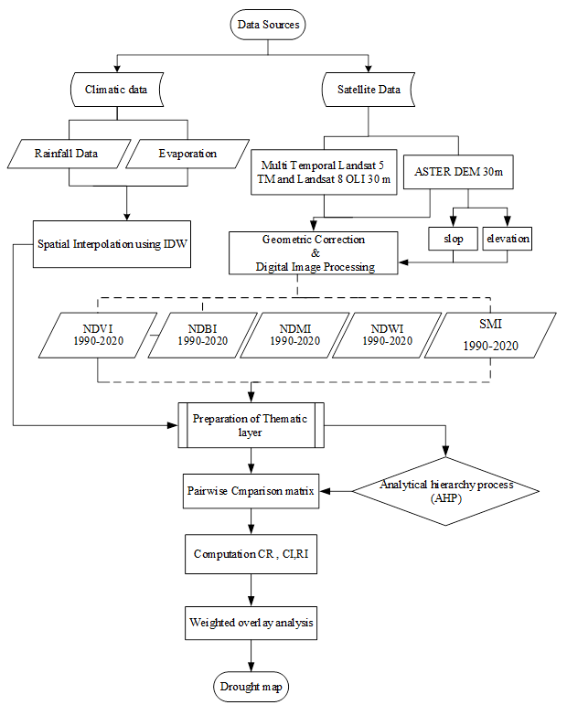

**Figure 2.** The flow diagram depicts the approach employed in the present study.

* 1. *Analytical hierarchy process*

A conditional variable pairwise matrix was generated using the AHP method. One well-known way to deal with the complex problems caused by drought susceptibility is the AHP method [38]. The approach ordered parameters hierarchically for pairwise comparison, using a comparative scale of integer numbers ranging from 1 to 9. A 12 x 12 pairwise reference matrix was used to compare each unit's value, with remaining values reflecting the relative significance of remaining variables. The ranking of each parameter was established by the comparison matrix, relative weight matrix, and normalized main eigenvector [39]. The matrix of pairwise comparisons is used to estimate the relative priority of alternatives based on specific criteria. This process, known as synthesis, calculates a composite weight for each alternative, with the highest overall rating being the final solution Table 3. The normalized principal eigen vector was estimated by dividing column values with the relative weight matrix, and effect percentages for each thematic layer were calculated. The consistency ratio (CR) was used to check the accuracy of the relation, with a ratio less than 0.1 indicating an appropriate reciprocal matrix and a ratio greater than 0.1 indicating matrix modification[40].The user's expertise, proficiency, and discernment, derived from previous experience, dictate the evaluation, fulfillment of the criteria, and decision-making process. Consequently, establishing the criteria and their rankings necessitates a logical technique. This subjective method requires it. This study utilized GIS for the geographical analysis of drought in the regional area. The Analytic Hierarchy Process (AHPi) was employed to construct pairwise comparison matrices and to calculate the weight factors for each parameter. This study calculates the weights and presents a list of them. The Table.1 delineates the assumptions for each criterion.

*Consistency ratio (CR) = CI/CR* *(1)*

where, CI refers to consistency index and RI is the random consistency index[41].

Table 3. Partial scores for each parameter based on the severity of the drought.

|  |  |  |  |  |
| --- | --- | --- | --- | --- |
| **S. No.** | **Parameter** | **Range value** | **Weight** | **Ranks** |
| **1** | NDMI | 0.3548 - 0.6403 0.6403 - 0.6787 0.678 - 0.7291 0.7291 - 0.7939 0.7939 - 0.9666 | 0.243 | 4 3 2 1 |
| **2** | ELEVATION | 0 - 16.768 16.76 - 20.75 20.75 - 25.73 25.73 - 31.70 31.70 - 85 | 0.0641 | 1 2 3 4 |
| **3** | Annual rainfall (mm) | 70.496 - 77.883 77.883 - 82.270 82.270 - 85.7330 85.733 - 90.465 90.465 - 99.931 | 0.25 | 4 3 2 1 |
| **4** | LST | 23.467 - 31.693 31.693 - 36.275 36.275 - 39.502 39.50 - 42.626 42.626 - 50.019 | 0.0693 | 1 2 3 4 |
| **5** | HUMIDTY | 2,168.7 - 2,443.8 2,443.8 -2,648.1 2,648.1 - 2,785.6 2,785.6 - 2,935.7 2,935.7 - 3,231.6 | 0.032 | 4 3 2 1 |
| **6** | NDVI | -0.7304- -0.1500 -0.1500 - -0.0149 -0.0149 - 0.10012 0.10012 - 0.1901 0.1901 - 0.545 | 0.3905 | 4 3 2 1 |
| **7** | Evaporation | 70.3193 - 76.320 76.32001 - 82.32 82.3206 - 88.321 88.3213 - 94.321 94.321 - 100.32 | 0.021 | 1 2 3 4 |
| **8** | NDBI | 0.96666 0.7963 0.79631 - -0.73153 -0.7315 3-0.68114- 0.68114- -0.6451 -0.64515 - -0.35483 | 0.1574 | 4 3 2 1 |
| **9** | SMI | 0.35483 - 0.64035 0.64035 - 0.6787 0.6787 - 0.72913 0.72913 - 0.7939 0.7939 - 0.9666 | 0.0282 | 4 3 2 1 |
| **10** | SPI | -0.10173 - 0.02390 0.02390 - 0.14953 0.149537 - 0.2751 0.2751 - 0.4008 0.40081 - 0.5264 | 0.0271 | 1 2 3 4 |
| **11** | LULC | Waterbodies Vegetation Built _up_ Area Agricultural Baer land | 0.041 | 1 2 3 4 |
| **12** | Slope (degree) | 0 - 1.1483  1.14835 - 2.1326 2.1326 - 3.609 3.60913 - 6.2339 6.2339 - 41.833 | 0.0169 | 1  2  3  4 |

*\* Weights are calculated using eigenvalue method*

*\* Mild drought—1, Moderate drought—2, Severe drought—3 and Extreme drought—4*

*3.2. Multi-Criteria Evaluation*

The amalgamation of GIS and MCDA has given rise to a novel study domain, referred to as GIS-MCDA. It harnesses both “hard” and “soft” data and is considered the most widely adopted method for LUSA today[42][33] . Multi-criteria analysis (MCA) begins with identifying a criterion, which can be a constraint or factor. This step requires extensive literature and expert knowledge. Criteria used in MCA come from different fields and have different units of measurement. To keep the tutorial simple, all criterions should be scaled or weighted into a common scale.

A minimum of criterions is used to ensure suitability. This project applied a Multi-Criteria Approach (MCA), GIS-based multicriteria decision analysis (GIS-MCDA) is one of the most widely applied techniques in land use suitability analysis. QGIS integrates GIS and (MCDA) for real-time data processing, layer management, customizable weighting, and dynamic visualization. It allows simultaneous application of MCDA methods on spatial data, assigning weights based on stakeholder priorities, and supports geospatial analysis tools like overlay and proximity analysis. The Tightly Coupled approach enhances MCDA capabilities without extensive programming or external tools[43]. It is pivotal that planners and analysts in the developing world have adequate support in conducting such analysis. Using Annual rainfall, Land Surface Temperature (LST) and Normalised Differenc Vegitation Index (NDVI) to assess the occurrence and spatial distribution of drought in Babylon city. Ultimately, Land Use and

Land Cover Classification (LCLU) was employed to assess the impact of Precipitation (P) and NDVI. This strategy facilitates the organization and analysis of intricate decisions by prioritizing the significance of each variables within the study environment as Fig.3.

The subsequent approach was utilized to construct this model:

(a) Identifying and choosing variables that signify drought intensity in the study area.

(b) Processing of distinct parameters in ArcMap.

(c) Evaluation and allocation of weight values to factors

(d) Reclassifying and evaluation of research variables

(e) Estimation of drought prevalence (pattern and  strength)

(f) Validation of the 'MCE' model in the aforementioned section (e)

In this study, two intelligent methods, namely Support Vector Machine SVM and Multi-Criteria Evaluation (MCE)were used to extract the drought vulnerability map of the central part of Iraq. Numerous studies have sought for possible groundwater zones by combining (GIS) and resource selection (RS) with multi-criteria decision-making analysis (MCDMA).

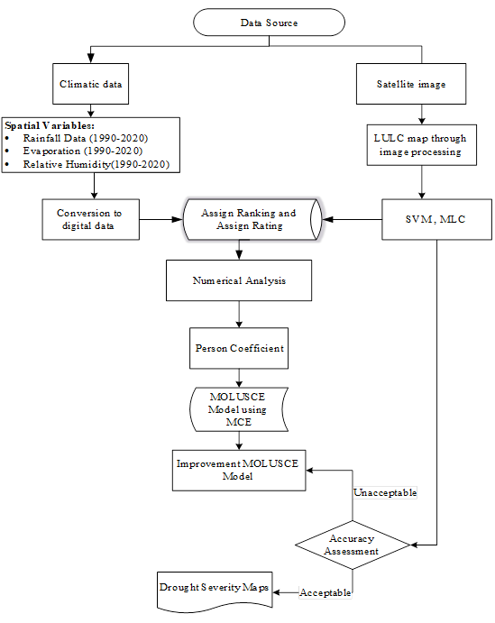

**Figure 3.** Flowchart for the present model.

*3.4. NDVI, NDMI, LST, and NDWI*

The NDVI is a commonly utilised vegetation index in studies on the environment., based on the reflections of plant cell structures. Healthy vegetation reflects more NIR radiation, while less in the red region. The greener a plant, the greater its reflectance, distinguishes surface materials[44]. NDVI is calculated for each image, regardless of the presence of red and “near-infrared” wavelength bands. NDVI images range from -1 to +1, with -1 indicating saturated water. And +1 signifies healthy vegetation. the NDVI for each image was calculate, regardless of the presence of red and near-infrared wavelength bands. [45][46].

*NDVI = (NIR- RED) / (NIR + RED) (2)*

The most severe drought was observed in the most districts, as indicated by the Land Surface Temperature (LA).

*NDWI = (NIR – Green) / (NIR + Green) (3)*

Since it computes using (NIR) and (SWIR) reflectance, it is responsive to variations in the amount of water vapour and porous mesophyll within plant canopies. [40]. The NDMI index was employed to ascertain the moisture content in plants, calculated using equation (4). This measure is valuable for evaluating plant vitality and moisture levels, aiding in the management of agricultural resources as equations [22][23].

*NDMI = (Band4 - Band5)/ (Band4+ Band5) (4)*

The NDBI was utilized to identify built-up or urban regions[47]. as equation below:

*NDBI = (SIWR –NIR) / (SIWR +NIR) (5)*

LST denotes the radiation skin temperature of the terrestrial surface, ascertained by a distant sensor. It is significantly contingent upon the measured surface, encompassing albedo, vegetation cover, and soil moisture. Factors like rooftops, forests, and agricultural areas significantly influence the surface temperature. LST is often measured using remote sensing satellites for large, quick, and cost-effective measurements. The LST was generated from Landsat 8 thermal band (Band 10) [48][47].

1. Conversion to Top-of-Atmosphere (TOA) Radiance

*L(λ) = ML x Band 10 + AL –Oi (6)*

*Where:*

L(λ): TOA spectral radiance

ML: Radiance multi-plicative band (from MTL txt)

AL: Radiance add band #10 (from MTL txt)

Oi: correction value (for Landsat 8 Band#10 its = 0.29)

1. Conversion to Top-of-Atmosphere (TOA) Brightness Temperature

$$BT =\frac{K2}{ln\left(\frac{k1}{L\left(λ\right)}+1\right)}–273.153 (7)$$

*Where*:

BT: Top of Atmosphere brightness temperature Co

L(λ): TOA spectral radiance K1& K2 constant for band#10

1. Normalized Difference Vegetation Index (NDVI)
2. Land Surfece Emisivity (LSE)

*PV = ((NDVI –NDVI min) / (NDVI max–NDVI min))2 (8)*

5. Land Surface Temperatures (LST)=

*LST = BT / (1+ (λ * BT / C2) * ln(E)) (9)*

*Where:*

BT: Top of Atmosphere brightness Temp.

λ: Wavelength of emitted radiance E : Land Surface Emisivity h: Plaink’s constant = 6.626 * 10-34Mk s: Boltzmani constant = 1.38*10-23JK c: velocity of light = 2.998*108m/s

**4. Weighted overlay analysis.**

The weighted overlay approach is a lucid and effective technique for assessing probable drought risk areas. Twelve environmental element maps were utilized to assess drought severity. Map depicting the zonation of the research area. The factors, organized by relevance, were awarded a numerical value on a scale from 1 to 5. The weights and grades were assigned to the classes of the factor. Increased weights and ranks signify a greater impact on drought events. To generate the drought risk zone map, these features were overlaid as thematic layers in GIS using the weighted overlay method methodology (Word of Mouth). The drought map was ultimately generated by multiplying all parameters by their corresponding weights. The drought map was categorized into five zones: No drought, Mild drought, Moderate drought, Severe drought, and Extreme drought.

$D=\sum_{i=1}^{n}{Tj×di}$*(10)*

where, Tj denotes the weights of each parameter multiplied to the drought parameters (di).

**5. Results and Discussion**

*5.1. NDVI, NDMI, LST, and NDBI*

Nevertheless, the “Normalized Difference Vegetation Index” (N) indicates that the dearth was uniformly distributed throughout the area of inquiry. In order to make a more well-informed decision during a dearth assessment, a multi-criteria approach that integrates pertinent parameters must be implemented.

A lack of water can affect the plant canopies during a drought, this can severely influence total plant development, resulting in reduced agricultural yields in farming regions. Identifying plant water stress preliminarily aids in averting such outcomes. Fig.4. Thus, it functions as a more effective indication of plant water stress.

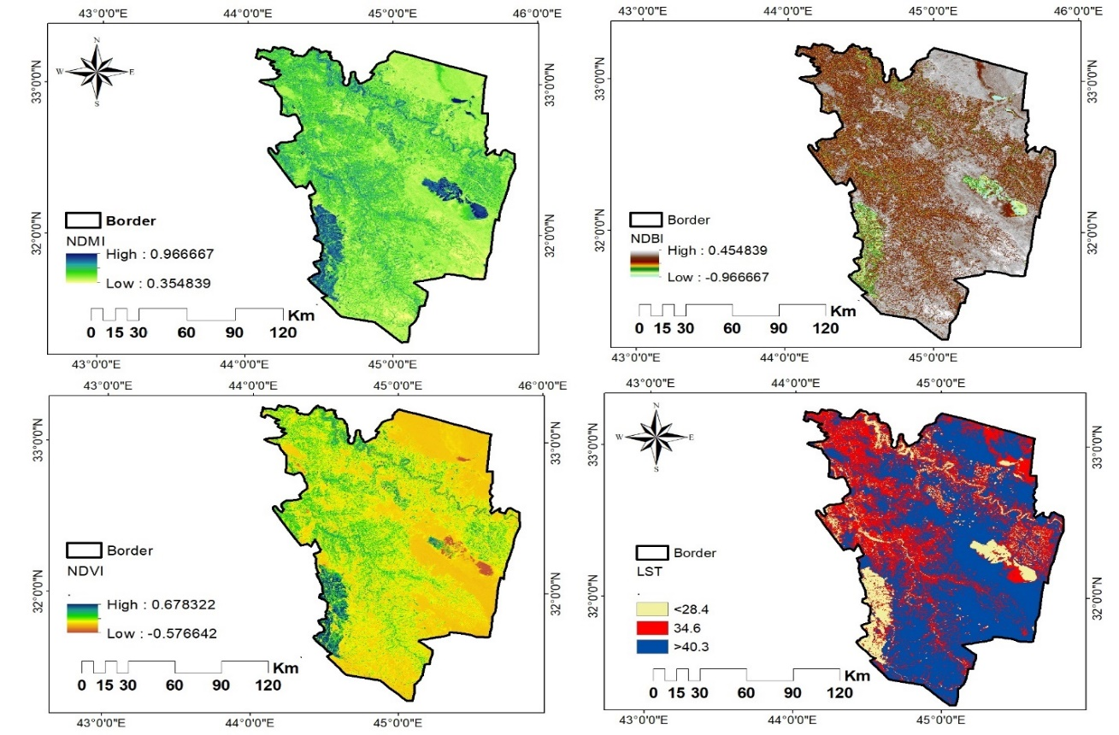

**Figure 4**. Thematic layers for drought analysis: NDVI, NDMI, NDBI, and LST.

*5.2. Soil moisture index SMI*

The most crucial element in agriculture for determining a drought indicator is soil moisture [49]. However, remote sensing methods improve soil moisture measurements in many regions. We use the Index of Soil Moisture (SMI) to assess drought severity, dividing it into "no drought" and "extreme drought" categories [49]. The SMI was calculated for the study area in June 1990, 2000, 2010, and 2020, using the drought function to predict the agricultural drought in those years. The statistics are appropriate for forecasting agricultural dryness, as a genuine drought transpired in the region from March to July. the conclusive SMI map was derived, also known as the agricultural drought map, All SMI operations were performed with ArcGIS 10.8 software as shown in Fig. 5.

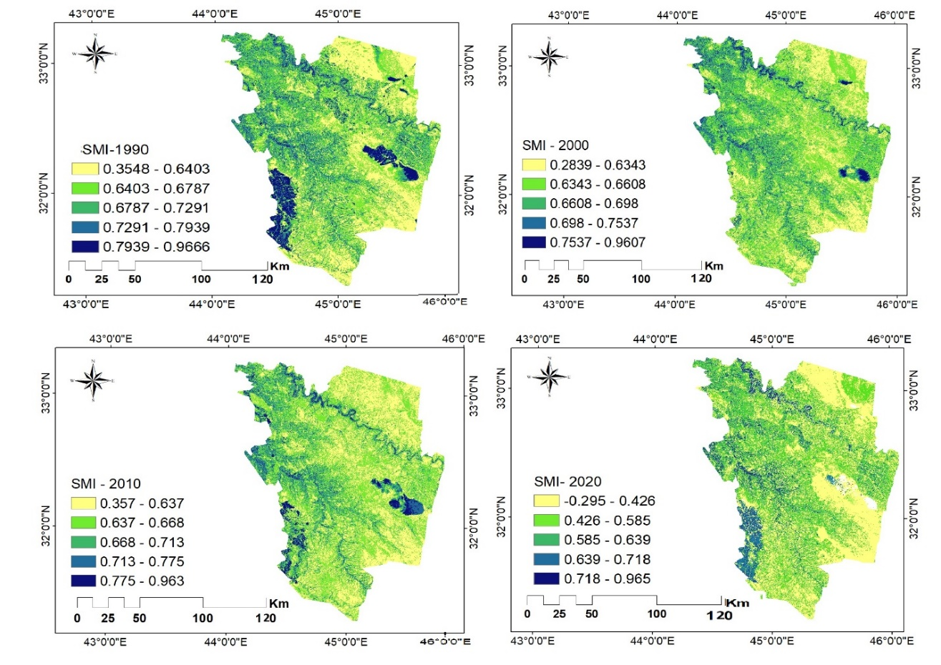

**Figure 5.** Thematic layers for drought analysis: SMI from 1990-2020.

*5.3. Elevation, aspect, slope and Curvature*

The supply of water is impacted by terrain altitude, therefore digital elevation models are essential for tackling climate change and managing emergencies. The research utilized SRTM DEM dataset with 30-meter resolution from USGS, indicating higher altitudes in the northern area and lower elevations in the southern region.

Slope to clarify its role as a modifier rather than an indicator of drought.that measures the angle of the ground surface relative to the horizontal plane. Water runoff is markedly greater across steeper terrain compared to the adjacent ground surface. Consequently, compared to steep plains, places with gentler slopes exhibit reduced sensitivity to droughts. Water runoff is considerably greater across steeper terrain compared to the adjacent ground surface. Consequently, compared to steep plains, places with gentler slopes exhibit reduced sensitivity to droughts[50][44]. The statistical results indicate that the slope in degrees spans from 0 to 6.25, with corresponding mean and (standard deviation values = 2.14). Aspect denotes the directional slope, with varied degrees of solar radiation that affect the hydrology of the research area. The hydrology has an effect on this parameter. Temperature, humidity, infiltration, runoff, and soil evaporation were the factors that were used to establish a value for each

class. The elevation variation from (-42 to 85) meters signify geographical diversity, potentially resulting from geological activity or fluvial processes that shaped the topography.

Curvature maps are important in identifying regions with significant surface runoff and in strategizing water distribution. values ranging from (-20.6 to 0) are predisposed to water accumulation, influencing water availability during arid periods, while values exceeding 10.3 signify hilly regions; furthermore, Values approaching zero signify a more level terrain with a reduced gradient[51]. This data can be utilized to evaluate the dangers linked to drought and to formulate strategies for their mitigationFig.6.



**Figure 6.** Thematic layers for drought analysis: a) elevation, b) slope, c) aspect and curvature.

*5.4. Annual rainfall, SPI, and temperature*

The study collected mean annual precipitation data from all meteorological sites in the study area, importing it into ArcGIS software for processing. The SPI index, derived from precipitation data, ought to incorporate supplementary factors such as temperature, humidity, ETo, and sunshine duration for improved drought assessments. The data was used to produce a map showing the regional variation of precipitation levels across the region. The data also served as an indicator for aridity generating monthly Standard Precipitation Index values (SPI). Fig.7 represents the rainfall distribution map of the region. Rainfall in this area occurs from June to September due to monsoon winds, The temperature in these sub-tropical regions is moderate to high. The maximum temperature varies from 23°C to 50°C, while the minimum temperature goes from 18°C to 28°C. Additionally, spatial data on temperature and other meteorological variables, including evapotranspiration and relative humidity, are taken into account.



**Figure 7.** Thematic layers for drought analysis: Rainfall distribution, Relative Humidity, Evaporation, SPI.

*5.5. LULC use SVM model*

The main way to get information about different forms of land cover from remotely sensed pictures (RS) is by classification, which turns the data into land cover classifications with their own unique bio geophysical functions[52][53]. Digital maps are the initial stage in creating a database containing all location measurements and information[54][55]. The study utilized machine learning algorithms to classify land cover in the Babylon Province and surrounding area, evaluating and selecting the best algorithm based on accuracy assessment matrices. Satellite images from Landsat-5 TM for 1990 were used, and ArcGIS 10.8 and ENVI 5.3 software were used to detect five land cover classes: Water Bodies, Built-Up Area, Agriculture and Bare Land. SVM is a highly accurate class recognition algorithm, particularly in complex data or non-linear boundaries. It outperforms other classification algorithms, particularly Random Forest, in high-dimensional datasets like remote sensing[56]. SVM can adjust class weights for imbalanced classes, ensuring underrepresented classes are not biased. It handles high-dimensional data well, making it an excellent choice for complex data. SVM can be combined with Random Forest to improve overall performance, enhancing classification accuracy[57]The results from the SVM technique had the most perfect accuracy out of the five classification algorithms used. Cultivated water comprises 3.32%, Built-up Land comprises 14.20 % of the area, Vegetation16.65 % of the area, Barren Land comprises 11.20%, and Agricultural Land comprises 59.57%. Consequently, due to its perceived sensitivity to drought, the agricultural group has the highest numerical weight value. As Table 4, the Thematic layersof LULC for drought analysis from 1990-2020 are shown in Fig. 8.

|  |  |  |  |  |  |  |
| --- | --- | --- | --- | --- | --- | --- |
| **Class color** | **1990 sq. km.** | **2020 sq. km.** | **change sq. km.** | **1990%** | **2020%** | **percentage change %** |
| **water bodies** | 648.53 | 736.63 | 88.11 | 2.9196 | 3.316 | 0.3966 |
| **built -up-area** | 2058.29 | 6259.00 | -4200.71. | 28.1770 | 9.266 | -18.9109 |
| **Vegetation** | 5113.96 | 3697.50 | -1416.46 | 23.0222 | 16.646 | -6.3767 |
| **Agriculture** | 7273.81 | 13232.11 | 5958.30. | 32.7455 | 59.569 | 26.8233 |
| **Bare land** | 2917.84 | 2488.60 | -429.24 | 13.1357 | 11.203 | -1.9324 |

Table 4. Summary of LULC analysis from 1990-2020.

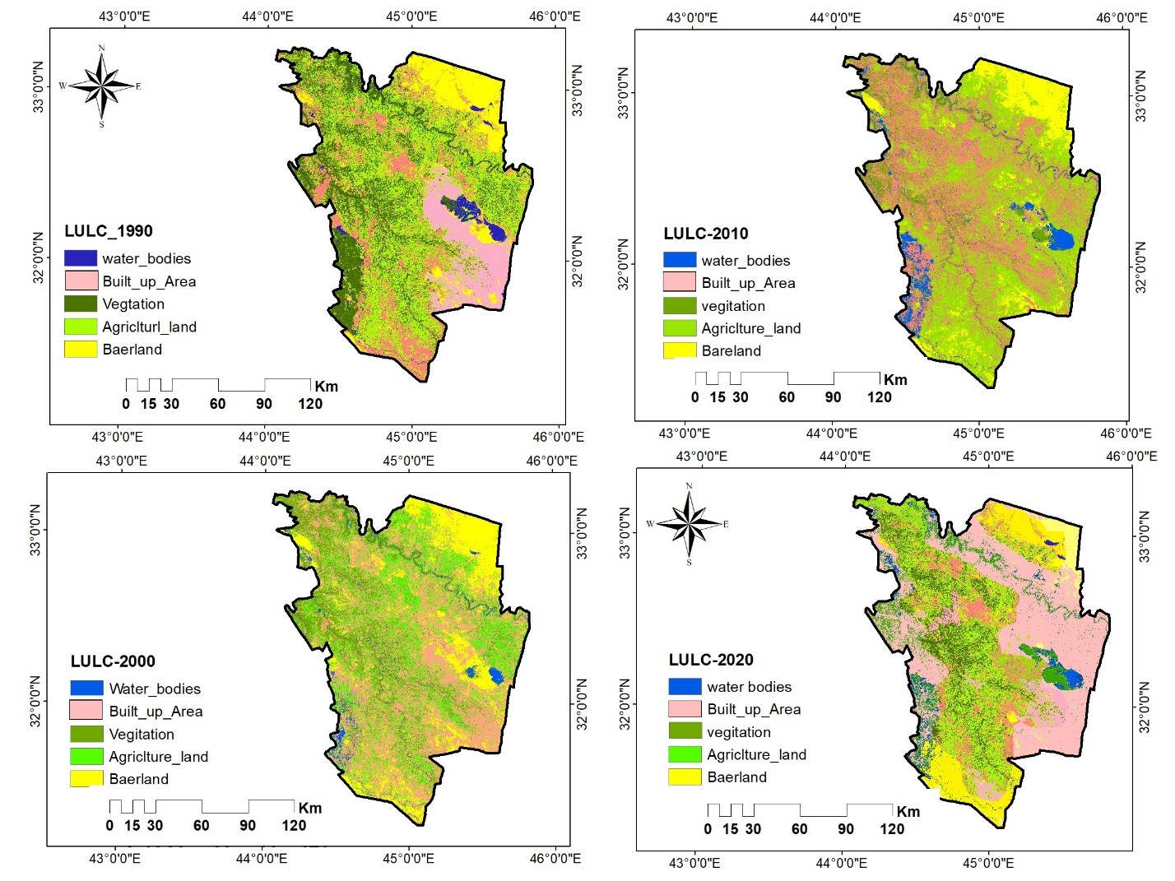

**Figure 8**. Thematic layers of LULC for drought analysis from 1990-2020.

*5.6. Development of ‘MCE’ model*

This work introduces a “multi-criteria decision-making (MCDM)” approach for generating an integrated Drought Vulnerability Assessment (DVA) map utilizing the Analytic Hierarchy Process (AHP) and geospatial methodologies. The proposed model for drought assessment uses geo-environmental parameters from ground-based datasets and satellite products. However, gauge observations exhibit discontinuity and low spatial resolution. Studying drought caused by major climatic changes in this region requires trustworthy, high-resolution data. Consequently**,** it is essential to comprehend the gravity and impacts of this drought in the research region. This research intends to investigate the incidence within the given framework of relevance. The regional variability of drought in Babylon.

The methodology was implemented in the study area, yielding an effective drought map. Fig9 displays the results of assessing the drought monitoring model's performance before it was created, using the Multiple Resolution Analysis (MCDA) method in QGIS. The figure includes the model accuracy measure, showing the percentage of correctness and Kappa values ​​across several categories. The model correctly classified 42.62% of the cases, as indicated. Kappa value reflects the model’s agreement with actual conditions. The displayed values ​​(0.17563) indicate a relatively poor agreement between predictions and reality, indicating the need for model improvement. The horizontal lines in the graph show the different levels of Kappa, which helps in evaluating the effectiveness of the model before modifications. On the other hand, Fig. 10. reflects the results after the model was developed, showing a significant performance improvement. The correctness percentage reaches 100%, indicating that all monitored data were correctly classified, reflecting the effectiveness of the model after modifications. The Kappa value is 1.0, indicating a perfect fit between the predictions and the actual drought conditions. This shows that the model has achieved a high level of accuracy and reliability in predicting drought conditions in the region. These results show how important it is to have enough geographic and numerical data to improve drought monitoring models. This makes the results from using MCDA more reliable when evaluating environmental conditions. Several studies, including Mishra and Singh, have employed MCDA to examine the effects of drought on agriculture[58]. The results showed a significant improvement in the accuracy of the models after improving the input data or analysis models. For example, before improving the model, the accuracy rate was around 50%, but after the modifications, the percentage increased to 90%, similar to what was achieved in your research. The images above show how the model's performance has improved from poor to excellent because of research advancements. This highlights the value of using spatial analysis tools like QGIS in environmental studies. When looking at Fig 9 and 10 alongside other research using multi-criteria analysis (MCDA) for drought monitoring or environmental risk assessment**,** Bai et al.also used the kappa value to check how well their model matched real data. Before the improvements, the kappa value ranged from 0.2 to 0.6, suggesting a moderate fit[59]. After applying the improvements, the study reported a kappa value of up to 0.85, reflecting a significant improvement in the model's reliability. In their research, they achieved an ideal kappa value (1.0) after the improvement, reflecting a remarkable superiority in performance. In addition, many researchers, such as Zhao et al.[60], emphasized the importance of geographic data as a key indicator for drought assessment. Their results showed that using multi-source data can enhance the accuracy of models, which is consistent with their research that emphasized the importance of quantitative and geographic data. Other studies, like Mao et al. (2020), have combined MCDA with other models, including neural network analysis, to enhance predictions[61]. This suggests the potential for expanding your research by incorporating additional methods to improve accuracy. The comparison shows that your research results are in line with general trends in the literature on drought monitoring and environmental risk assessment. Your high accuracy and strong kappa value from using the MCDA approach show great success. This improves the model's reliability and highlights the importance of the input data. These results support the need to use multiple analysis methods to improve our understanding of complex environmental conditions.

 

**Figure 9.** Evaluation of Drought Monitoring Performance Using Multi-Resolution MCDA in QGIS" before developing (by researcher).

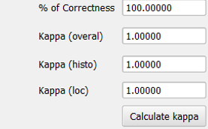 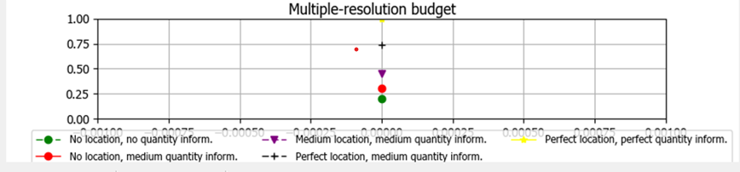

**Figure 10.** Evaluation of Drought Monitoring Performance Using Multi-Resolution MCDA in QGIS" after developing (by researcher)

The research indicates that AHP and GIS are applicable for assessing drought risk, facilitating drought management strategies and diminishing crop resilience. This research created twelve pairwise comparison matrices to identify locations at risk of drought. The matrices were founded on criteria, sub-criteria, and elements, including climatic, socio-economic, and soil-land usage factors. After ranking the options according to the parameters, we used the eigenvalue method to find the weights of each matrix. A synthesis technique was employed to determine overall priorities, wherein each ranking was multiplied by the priority of its corresponding criterion or sub-criterion and summed to obtain its ultimate priority**.** This study developed twelve pairwise comparison matrices: one for the criteria related to the goal, presented in Table 5, and eight for the sub criteria**.** In the analysis presented in Table 5, the weights assigned to various parameters are important because they determine their significance in assessing drought vulnerability. The weights reflect the relative importance of each parameter in influencing drought conditions in the study area. The weights assigned in Table 5 reflect a thoughtful prioritization of parameters based on their relevance to drought assessment. High weights for NDVI and NDMI, 0.423 and and0.251 respectively, indicate their critical roles in understanding vegetation health and moisture availability, which are essential for evaluating drought conditions. In contrast, parameters like slope and elevation, while important for contextual understanding, are less directly related to immediate drought impacts, justifying their lower weights. Elevation can impact precipitation patterns and temperature, while slope affects runoff; however, their influence is less direct compared to parameters like NDVI and NDMI. Their roles are more about contextualizing the landscape rather than directly measuring drought severity. This nuanced approach allows for a more accurate and comprehensive assessment of drought vulnerability in the study area.

Table 5. The chosen parameters for the drought delineation paired-wise comparison matrix.

|  |  |  |  |  |  |  |  |  |  |  |  |  |
| --- | --- | --- | --- | --- | --- | --- | --- | --- | --- | --- | --- | --- |
| **Factor** | **NDVI** | | **NDMI** | **NDBI** | **LST** | **elevation** | **SMI** | **SPI** | **Slope** | **Eigenvalue (Eg)** | | **weight** |
| **NDVI** | 1 | | 3 | 5 | 8 | 7 | 9 | 9 | 8 | 5.21 | | 0.390 |
| **NDMI** | 0.333 | | 1 | 3 | 7 | 4 | 8 | 7 | 8 | 3.25 | | 0.243 |
| **NDBI** | 0.2 | | 0.333 | 1 | 5 | 3 | 7 | 6 | 9 | 2.099 | | 0.157 |
| **LST** | 0.125 | | 0.143 | 0.2 | 1 | 2 | 5 | 3 | 5 | 0.924 | | 0.069 |
| **elevation** | 0.143 | | 0.25 | 0.333 | 0.5 | 1 | 4 | 3 | 4 | 0.855 | | 0.064 |
| **SMI** | 0.111 | | 0.125 | 0.143 | 0.2 | 0.25 | 1 | 2 | 2 | 0.375 | | 0.028 |
| **SPI** | 0.111 | | 0.143 | 0.167 | 0.333 | 0.3333 | 0.5 | 1 | 2 | 0.361 | | 0.027 |
| Slope | 0.125 | | 0.125 | 0.111 | 0.2 | 0.25 | 0.5 | 0.5 | 1 | 0.261 | | 0.019 |
| **Total** |  | |  |  |  |  |  |  |  | 13.344 | | 1.00 |
| **Number of Criteria** | 8 | |  |  |  |  |  |  |  |  | |  |
| **C. I. =** | 0.116 | | | | | | | | | |  |  |
| **R. I. =** | 1.41 | | | | | | | | | |  |  |
| **C. R. %** | | = 8.261 Consistency OK | | | | | | | | |  |  |

The first sub-criteria matrix, concerning climatic factors (annual rainfall, monthly evaporation,LULC, and humidity), is provided in Table 5. The matrices for the sub-criteria under socio-economic factors and soil-land use are displayed in Table 6. Ultimately, twelve comparison matrices were computed for the four possibilities concerning all parameters. In Table 4, the criteria on the left are compared sequentially against each criterion at the top to ascertain which is more significant in relation to the objective of identifying drought risk zones. The synthesis technique was employed to determine the overall priorities; specifically, each ranking must be multiplied by the priority of its corresponding criterion or sub-criterion, and the resultant weights for each choice must be summed to obtain its ultimate priority. Weight values are absolute numbers between zero and 100% assigned to study indices, ensuring a 100% sum of weights for all parameters. They are often based on expert knowledge, analytical procedures, and literature.

Table 6. Pairwise comparison matrix for sub-criteria concerning climatic conditions

|  |  |  |  |  |  |  |
| --- | --- | --- | --- | --- | --- | --- |
| **Factor** | **Annual Rainfall** | **Relative Humidity** | **Evaporation** | **LULC** | **Eigenvalue (Eg)** | **weight** |
| **Annual Rainfall** | 1.000 | 3.000 | 5.000 | 8.000 | 3.310 | 0.557 |
| **Relative Humidity** | 0.333 | 1.000 | 3.000 | 7.000 | 1.627 | 0.274 |
| **Evaporation** | 0.200 | 0.333 | 1.000 | 5.000 | 0.760 | 0.128 |
| **LULC** | 0.125 | 0.143 | 0.200 | 1.000 | 0.244 | 0.041 |
| **Total** |  |  |  |  | 5.941 | 1.00 |
| **Numberof Criteria =** | 4 |  |  |  |  |  |
| **C. I. =** | 0.067 |  |  |  |  |  |
| **R. I. =** | 0.890 |  |  |  |  |  |
| **C. R. % =** | 7.56 | Consistency | OK |  |  |  |

The results of the Pearson correlation coefficient calculation are displayed in Table 7. NDMI, NDVI elevation, precipitation LST, Relative humidity, evaporation, and Aspect were determined to have high correlations with each other after comparison. To measure the variables for correlation, this research makes use of ratio as well as interval scale patterns.

Table 7. The Pearson correlation coefficient quantifies the link between different variables.

|  |  |  |  |  |  |  |  |  |  |
| --- | --- | --- | --- | --- | --- | --- | --- | --- | --- |
|  | **NDMI** | **elevation** | **perception** | **LST** | **humidity** | **NDVI** | **evaporation** | **Aspect** | **slope** |
| **NDMI** | 1 | 0.1769 | -0.022 | -0.787 | -0.039 | 0.667 | -0.022 | -0.031 | -0.189 |
| **elevation** |  | .1 | 0.638 | -0.244 | -0.238 | 0.258 | 0.638 | 0.014 | 0.046 |
| **perception** |  |  | 1 | -0.103 | -0.096 | -0.026 | 1.000 | 0.005 | 0.004 |
| **LST** |  |  |  | 1 | 0.055 | -0.555 | -0.103 | 0.029 | 0.149 |
| **humidity** |  |  |  |  | 1 | 0.005 | -0.096 | 0.005 | 0.009 |
| **NDVI** |  |  |  |  |  | 1 | -0.026 | 0.023 | 0.127 |
| **evaporation** |  |  |  |  |  |  | 1 | 0.005 | 0.004 |
| **Aspect** |  |  |  |  |  |  |  | 1 | 0.062 |
| **slope** |  |  |  |  |  |  |  |  | 1 |

Figure 11 presents a detailed spatial analysis of drought severity within the study area. The map clearly delineates various regions classified according to their drought conditions. Notably, the southwestern and scattered northeastern sections are experiencing moderate drought conditions, indicating that these areas are facing significant water stress, which can adversely affect agriculture, local ecosystems, and water supply.The northwest region stands out as the most severely affected, marked by intense drought conditions. This concentration of severe drought raises alarming concerns, as it suggests that a substantial portion of the landscape is unable to support vegetation and agricultural activities. The map’s color gradient effectively communicates the severity of drought, with darker shades indicating areas of extreme drought risk.Furthermore, the majority of the research area is under substantial drought stress, which could have cascading effects on local communities and economies. The depiction of drought severity in this figure underscores the urgency for immediate and targeted interventions. Policymakers must recognise the vulnerability of these regions to devise effective strategies for water management and resource allocation.Figure 12 complements the information presented in Figure 11 by quantifying the percentage of land areas affected by different drought categories. This bar graph succinctly breaks down the distribution of drought conditions.A serious drought is affecting the area primarily. With about 59.5% of the region experiencing severe drought and acute water shortages for the populace, this degree of drought might lead to significant crop loss. If these problems persist, regional and municipal leaders must act quickly. Although moderate drought is less prevalent than severe drought (16.1%), it nevertheless represents a crucial area that has to be monitored and perhaps addressed. Implementing water conservation methods is necessary due to the potential negative impact of this level of drought on agricultural output. Still, many areas hit hard by the drought (11.2%) were in a precarious situation that might get worse quickly if nothing is done. It is important to note that climate variability may worsen these conditions, even though only 9.5% of the area is considered to be under mild drought. Given that only 3.3% of the region's landmass was unaffected by the drought, effective drought control measures are crucial.The analysis underscores the necessity for policymakers and planners to develop effective strategies to mitigate the impacts of drought, particularly in the most affected regions.Given the projections of climate change, which are likely to exacerbate these conditions, proactive measures are essential. Strategies may include improved water conservation techniques, investment in drought-resistant crops, and the implementation of policies aimed at sustainable land use. The figures serve as a poignant illustration of the urgent need for action to address the challenges posed by drought in this vulnerable region.

The current drought analysis was conducted utilising AHP and GIS, offering valuable insights on drought monitoring in Babylon city and its vicinity. The study relies heavily on the researcher's discretion and employs GIS to detect drought conditions based on twelve important parameters; it also handles problems with parameter management and the spatial variability of the input data[62] [63]. The findings provided more evidence that central and southern Iraq would be the hardest hit by future droughts. Politicians in Iraq can use the aforementioned findings to gauge the likelihood of future droughts. Creating effective adaptation plans to tackle climate change could also benefit from this.

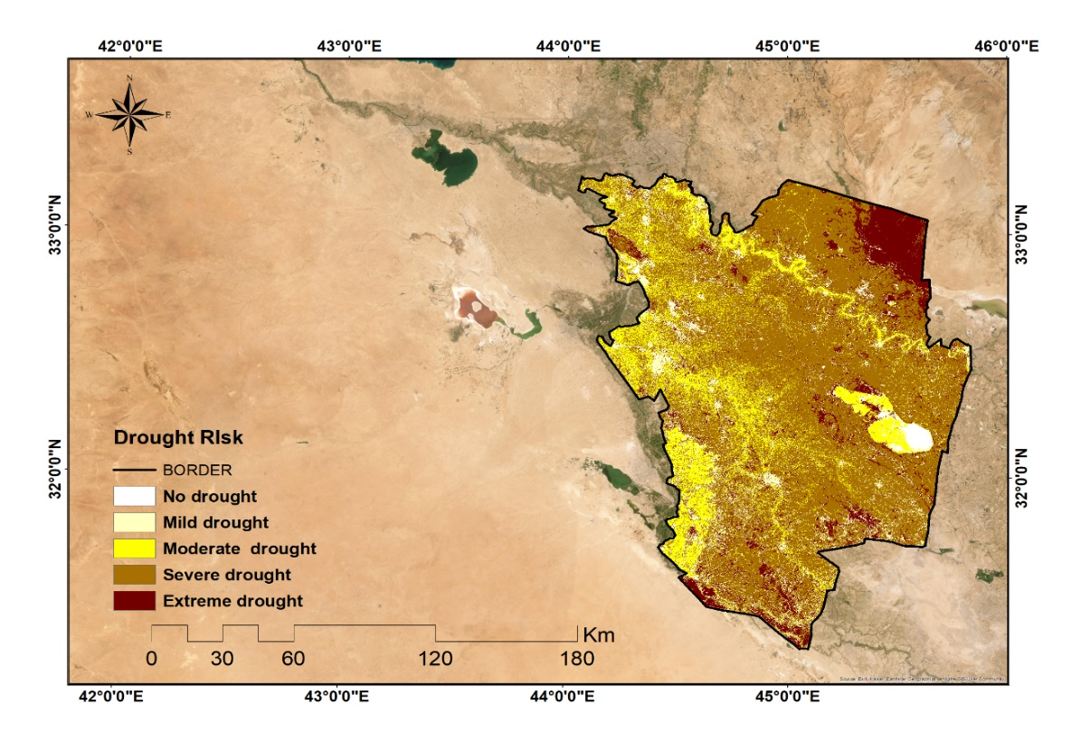

**Figure** **11**. Distribution of the research area's susceptibility to drought by space.

**Figure** **12.** Area proportion of drought categories for the study area.

1. **Conclusion**

The research employs AHP and GIS to evaluate drought risk in Babylon City and its adjacent regions in Iraq. The study found a significant drought in the southwestern region, particularly in the northwestern section, which affected 70% of the territory with severe drought conditions. The study area is devoid of mild drought conditions. The AHP and GIS model of drought risk, assisting decision-makers, investors, and stakeholders in improving water resource management and spatial water conservation in arid and semi-arid areas.

**References**

[1] A. Buras, A. Rammig, and C. S. Zang, “Quantifying impacts of the 2018 drought on European ecosystems in comparison to 2003,” *Biogeosciences*, vol. 17, no. 6, pp. 1655–1672, 2020.

[2] O. Hoegh Guldberg *et al.*, “Impacts of 1.5 C global warming on natural and human systems,” 2018.

[3] “https://www.who.int/health-topics/drought#tab=tab_1&nbsp; No Title.”

[4] D. N. Khoi, T. T. Sam, P. T. Loi, B. V. Hung, and V. T. Nguyen, “Impact of climate change on hydro-meteorological drought over the Be River Basin, Vietnam,” *J. Water Clim. Chang.*, vol. 12, no. 7, pp. 3159–3169, 2021.

[5] B. S. Jasim, O. Z. Jasim, and A. N. AL-Hameedawi, “Monitoring Change Detection of Vegetation Vulnerability Using Hotspots Analysis,” *IIUM Eng. J.*, vol. 25, no. 2, pp. 116–129, 2024, doi: 10.31436/iiumej.v25i2.3030.

[6] S. Rehman, M. S. U. Hasan, A. K. Rai, M. H. Rahaman, R. Avtar, and H. Sajjad, “Integrated approach for spatial flood susceptibility assessment in Bhagirathi sub‐basin, India using entropy information theory and geospatial technology,” *Risk Anal.*, vol. 42, no. 12, pp. 2765–2780, 2022.

[7] M. S. U. Hasan *et al.*, “Hydrometeorological consequences on the water balance in the Ganga river system under changing climatic conditions using land surface model,” *J. King Saud Univ.*, vol. 34, no. 5, p. 102065, 2022.

[8] R. A. Rather *et al.*, “Anthropogenic impacts on phytosociological features and soil microbial health of Colchicum luteum L. an endangered medicinal plant of North Western Himalaya,” *Saudi J. Biol. Sci.*, vol. 29, no. 4, pp. 2856–2866, 2022.

[9] UNCCD, “Drought in numbers 2022‐restoration for readiness and resilience,” United Nations Expert Group Meeting on Population Distribution, Urbanization …, 2022.

[10] G. G. Haile, Q. Tang, W. Li, X. Liu, and X. Zhang, “Drought: Progress in broadening its understanding,” *Wiley Interdiscip. Rev. Water*, vol. 7, no. 2, p. e1407, 2020.

[11] FAO, “Proactive Approaches to Drought Preparedness—where are we now and where do we go from here?,” *FAO*. Food and Agriculture Organization of the United Nations Rome, Italy, 2019.

[12] M. Beroho *et al.*, “Future scenarios of land use/land cover (LULC) based on a CA-markov simulation model: case of a mediterranean watershed in Morocco,” *Remote Sens.*, vol. 15, no. 4, p. 1162, 2023.

[13] T. D. Bhaga, T. Dube, M. D. Shekede, and C. Shoko, “Impacts of climate variability and drought on surface water resources in Sub-Saharan Africa using remote sensing: A review,” *Remote Sens.*, vol. 12, no. 24, p. 4184, 2020.

[14] A. S. J. Al-Saedi, Z. M. Kadhum, and B. S. Jasim, “Land use and land cover analysis using geomatics techniques in Amara City,” *Ecol. Eng*, vol. 9, pp. 161–169, 2023.

[15] M. J. Rasheed and F. K. M. Al-Ramahi, “Detection of the impact of climate change on desertification and sand dunes formation East of the Tigris River in Salah Al-Din Governorate using remote sensing techniques,” *Iraqi Geol. J.*, pp. 69–83, 2021.

[16] E. Elhacham, L. Ben-Uri, J. Grozovski, Y. M. Bar-On, and R. Milo, “Global human-made mass exceeds all living biomass,” *Nature*, vol. 588, no. 7838, pp. 442–444, 2020.

[17] O. Jasim, K. Hasoon, and N. Sadiqe, “Mapping LCLU Using Python Scripting,” *Eng. Technol. J.*, vol. 37, no. 4A, pp. 140–147, 2019, doi: 10.30684/etj.37.4a.5.

[18] S. Legg, “IPCC, 2021: Climate change 2021-the physical science basis,” *Interaction*, vol. 49, no. 4, pp. 44–45, 2021.

[19] A. Stock, G. Bourne, W. Steffen, and T. Baxter, *Passing Gas: Why renewables are the future*. Climate Council, 2020.

[20] Q. Quan, S. Gao, Y. Shang, and B. Wang, “Assessment of the sustainability of Gymnocypris eckloni habitat under river damming in the source region of the Yellow River,” *Sci. Total Environ.*, vol. 778, p. 146312, 2021.

[21] S. Cao *et al.*, “Effects and contributions of meteorological drought on agricultural drought under different climatic zones and vegetation types in Northwest China,” *Sci. Total Environ.*, vol. 821, p. 153270, 2022.

[22] S. V Gaikwad, A. D. Vibhute, and K. V Kale, “Assessing Meteorological Drought and Detecting LULC Dynamics at a Regional Scale Using SPI, NDVI, and Random Forest Methods,” *SN Comput. Sci.*, vol. 3, no. 6, p. 458, 2022, doi: 10.1007/s42979-022-01361-0.

[23] M. García-Valdecasas Ojeda *et al.*, “Assessing future drought conditions over the Iberian Peninsula: the impact of using different periods to compute the SPEI,” *Atmosphere (Basel).*, vol. 12, no. 8, p. 980, 2021.

[24] R. Mousavi, D. Johnson, R. Kroebel, and J. Byrne, “Analysis of historical drought conditions based on SPI and SPEI at various timescales in the South Saskatchewan River Watershed, Alberta, Canada,” *Theor. Appl. Climatol.*, vol. 153, no. 1, pp. 873–887, 2023.

[25] J. Zhao, Q. Liu, H. Lu, Z. Wang, K. Zhang, and P. Wang, “Future droughts in China using the standardized precipitation evapotranspiration index (SPEI) under multi-spatial scales,” *Nat. Hazards*, vol. 109, pp. 615–636, 2021.

[26] S. Popović *et al.*, “Optimization of Artificial Intelligence Algorithm Selection: PIPRECIA-S Model and Multi-Criteria Analysis,” *Electronics*, vol. 14, no. 3, p. 562, 2025.

[27] Z. M. Kadhum, B. S. Jasim, and M. K. Obaid, “Change detection in city of Hilla during period of 2007-2015 using Remote Sensing Techniques,” *IOP Conf. Ser. Mater. Sci. Eng.*, vol. 737, no. 1, p. 12228, Feb. 2020, doi: 10.1088/1757-899X/737/1/012228.

[28] S. Zare Naghadehi, M. Asadi, M. Maleki, S.-M. Tavakkoli-Sabour, J. L. Van Genderen, and S.-S. Saleh, “Prediction of urban area expansion with implementation of MLC, SAM and SVMs’ classifiers incorporating artificial neural network using landsat data,” *ISPRS Int. J. Geo-Information*, vol. 10, no. 8, p. 513, 2021.

[29] T. Babu, R. Selvanarayanan, T. Thanarajan, and S. Rajendran, “Integrated early flood prediction using sentinel-2 imagery with VANET-MARL-based deep neural RNN,” *Glob. Nest J.*, vol. 26, no. 10, 2024, doi: 10.30955/gnj.06554.

[30] S. Karthik, R. Surendran, S. K. G. V, and S. Srinivasulu, “Flood prediction in Chennai based on extended elman spiking neural network using a robust chaotic artificial hummingbird optimizer,” vol. 27, no. 4, 2025.

[31] A. M. Selvi Sundarapandi, Y. Alotaibi, T. Thanarajan, and S. Rajendran, “Archimedes optimisation algorithm quantum dilated convolutional neural network for road extraction in remote sensing images,” *Heliyon*, vol. 10, no. 5, p. e26589, 2024, doi: 10.1016/j.heliyon.2024.e26589.

[32] Y. Alotaibi, B. Rajendran, K. G. Rani, and S. Rajendran, “Dipper throated optimization with deep convolutional neural network-based crop classification for remote sensing image analysis,” *PeerJ Comput. Sci.*, vol. 10, pp. 1–22, 2024, doi: 10.7717/peerj-cs.1828.

[33] T. H. Shihab, A. N. Al-Hameedawi, and A. M. Hamza, “Random forest (RF) and artificial neural network (ANN) algorithms for LULC mapping,” *Eng. Technol. J.*, vol. 38, no. 4A, pp. 510–514, 2020.

[34] A. N. M. Al-Hameedawi, “Fuzzy logic approach based on geomatics and remote sensing for siting a petroleum warehouse in the metropolitan area of Baghdad,” *J. Indian Soc. Remote Sens.*, vol. 50, no. 7, pp. 1211–1225, 2022.

[35] N. Adimalla and A. K. Taloor, “Hydrogeochemical investigation of groundwater quality in the hard rock terrain of South India using Geographic Information System (GIS) and groundwater quality index (GWQI) techniques,” *Groundw. Sustain. Dev.*, vol. 10, p. 100288, 2020.

[36] I. E. Issa, N. Al-Ansari, G. Sherwany, and S. Knutsson, “Expected future of water resources within Tigris–Euphrates rivers basin, Iraq,” *J. Water Resour. Prot.*, vol. 6, no. 5, pp. 421–432, 2014.

[37] F. A. O. AQUASTAT, “Transboundary River Basins–Euphrates-Tigris River Basin,” *Rome Food Agric. Organ. United Nations*, 2009.

[38] V. L. Sivakumar, R. R. Krishnappa, and M. Nallanathel, “Drought vulnerability assessment and mapping using Multi-Criteria decision making (MCDM) and application of Analytic Hierarchy process (AHP) for Namakkal District, Tamilnadu, India,” *Mater. Today Proc.*, vol. 43, pp. 1592–1599, 2021.

[39] T. L. Saaty, “Decision making with the analytic hierarchy process,” *Int. J. Serv. Sci.*, vol. 1, no. 1, pp. 83–98, 2008.

[40] P. Kahkashan, B. Najat, S. Iram, and S. Iffat, “Influence of soil type on the growth parameters, essential oil yield and biochemical contents of Mentha arvensis L.,” *J. Essent. Oil Bear. Plants*, vol. 19, no. 1, pp. 76–81, 2016.

[41] S. Yahaya, N. Ahmad, and R. F. Abdalla, “Multicriteria analysis for flood vulnerable areas in Hadejia-Jama’are River basin, Nigeria,” *Eur. J. Sci. Res.*, vol. 42, no. 1, pp. 71–83, 2010.

[42] C. Luan, R. Liu, and S. Peng, “Land-use suitability assessment for urban development using a GIS-based soft computing approach: A case study of Ili Valley, China,” *Ecol. Indic.*, vol. 123, p. 107333, 2021.

[43] K. Solaimani, F. Shokrian, and S. Darvishi, “An assessment of the integrated multi-criteria and new models efficiency in watershed flood mapping,” *Water Resour. Manag.*, vol. 37, no. 1, pp. 403–425, 2023.

[44] S. Wolff, S. Hüttel, C. Nendel, and T. Lakes, “Agricultural landscapes in Brandenburg, Germany: an analysis of characteristics and spatial patterns,” *Int. J. Environ. Res.*, vol. 15, pp. 487–507, 2021.

[45] I. A. Alwan, N. A. Aziz, and M. N. Hamoodi, “Potential water harvesting sites identification using spatial multi-criteria evaluation in Maysan Province, Iraq,” *ISPRS Int. J. Geo-Information*, vol. 9, no. 4, 2020, doi: 10.3390/ijgi9040235.

[46] M. A. Sresto, S. Siddika, M. N. Haque, and M. Saroar, “Application of fuzzy analytic hierarchy process and geospatial technology to identify groundwater potential zones in north-west region of Bangladesh,” *Environ. Challenges*, vol. 5, p. 100214, 2021.

[47] G. Grigoraș and B. Urițescu, “Land use/land cover changes dynamics and their effects on surface urban heat island in Bucharest, Romania,” *Int. J. Appl. Earth Obs. Geoinf.*, vol. 80, pp. 115–126, 2019.

[48] A. Al Kafy *et al.*, “Impact of LULC changes on LST in Rajshahi district of Bangladesh: a remote sensing approach,” *J. Geogr. Stud.*, vol. 3, no. 1, pp. 11–23, 2020.

[49] B. S. Jasim, O. Z. Jasim, and A. N. AL-Hameedawi, “Calculation soil moisture index (SMI) from Landsat-5 thematic mapper (TM) satellite images,” in *AIP Conference Proceedings*, AIP Publishing, 2024.

[50] H. K. Jabbar, M. N. Hamoodi, and A. N. Al-Hameedawi, “Variation in diurnal and seasonal surface urban heat island intensity across different climatic zones,” in *AIP Conference Proceedings*, AIP Publishing, 2023.

[51] M. N. Albana, “Food Security and The Current Situation in Iraq,” *NTU J. Adm. Hum. Sci.*, vol. 3, no. 4, pp. 173–200, 2023.

[52] B. S. Jasim, O. Z. Jasim, and A. N. AL-Hameedawi, “Evaluating land use land cover classification based on machine learning algorithms,” *Eng. Technol. J.*, vol. 42, no. 5, pp. 557–568, 2024.

[53] B. S. Jasim, O. Z. Jasim, and A. N. AL-Hameedawi, “A review for vegetation vulnerability using artificial intelligent (AI) techniques,” in *AIP Conference Proceedings*, AIP Publishing, 2024.

[54] B. S. Jasim, Z. M. K. Al-Bayati, and M. K. Obaid, “Accuracy of horizontal coordinates of cadastral maps after geographic regression and their modernization using gis techniques,” *Int. J. Civ. Eng. Technol.*, vol. 9, no. 11, pp. 1395–1403, 2018.

[55] Z. M. Kadhum, B. S. Jasim, and A. S. J. Al-Saedi, “Improving the spectral and spatial resolution of satellite image using geomatics techniques,” *AIP Conf. Proc.*, vol. 2776, no. April, 2023, doi: 10.1063/5.0138463.

[56] A. Statnikov, L. Wang, and C. F. Aliferis, “A comprehensive comparison of random forests and support vector machines for microarray-based cancer classification,” *BMC Bioinformatics*, vol. 9, pp. 1–10, 2008.

[57] T. Adugna, W. Xu, and J. Fan, “Comparison of random forest and support vector machine classifiers for regional land cover mapping using coarse resolution FY-3C images,” *Remote Sens.*, vol. 14, no. 3, p. 574, 2022.

[58] A. K. Mishra and V. P. Singh, “Drought modeling - A review,” *Journal of Hydrology*, vol. 403, no. 1–2. pp. 157–175, Jun. 06, 2011. doi: 10.1016/j.jhydrol.2011.03.049.

[59] Q. Liu, S. Zhang, H. Zhang, Y. Bai, and J. Zhang, “Monitoring drought using composite drought indices based on remote sensing,” *Sci. Total Environ.*, vol. 711, p. 134585, 2020.

[60] S. Jiang, L. Ren, M. Zhou, B. Yong, Y. Zhang, and M. Ma, “Drought monitoring and reliability evaluation of the latest TMPA precipitation data in the Weihe River Basin, Northwest China,” *J. Arid Land*, vol. 9, pp. 256–269, 2017.

[61] N. Noureldeen, K. Mao, A. Mohmmed, Z. Yuan, and Y. Yang, “Spatiotemporal drought assessment over sahelian countries from 1985 to 2015,” *J. Meteorol. Res.*, vol. 34, no. 4, pp. 760–774, 2020.

[62] M. Naem, R. Corner, and A. Dewan, “Diurnal and seasonal surface temperature variations: A case study in Baghdad,” in *Proceedings of the 3rd Annual Conference of Research@ Locate*, 2016, pp. 12–14.

[63] bassim mohammed hashim, E. A. Alraheem, N. A. Jaber, M. Jamei, and F. Tangang, “Assessment of Future Meteorological Drought Under Representative Concentration Pathways (RCP8.5) Scenario: Case Study of Iraq,” *Knowledge-Based Eng. Sci.*, vol. 3, no. 3, pp. 64–82, 2022, doi: 10.51526/kbes.2022.3.3.64-82.