A Study on Cement-free Geopolymer Concrete incorporated with industrial waste Cured at Open Environment for different molarities of sodium hydroxide
M Sasi Rekha*¹ and S R Sumathy²
¹Assistant Professor, Department of Civil Engineering, Government College of Engineering, Tirunelveli, Taminadu, India.
²Assistant Professor, Department of Civil Engineering, Alagapa Chettiar Government College of Engineering and Technology, Karaikudi, Taminadu, India.
*Corresponding author mail id: msasirekha.gce@gmail.com

Graphical Abstract
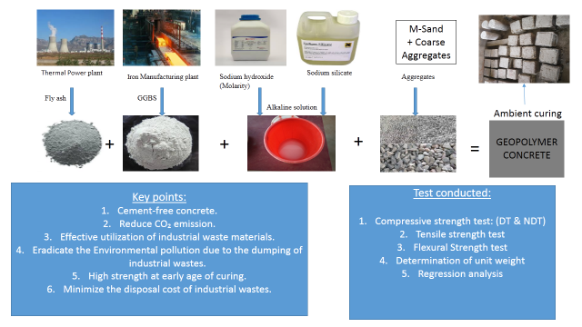

Abstract
Nowadays, the increase in population and industrial growth that generates lot of waste products which creates disposal problems and severe environmental hazards. The cement industry is one of the important sectors which liberates greenhouse gas such as carbon dioxide. The consumption of waste products which eradicate the disposal issues and also it diminishes the emission of greenhouse gases to the environment. This is an important reason for the introduction of cement-free Geopolymer Concrete. This paper was invented to understand the suitability of Geopolymer Concrete cured at ambient temperature in the construction industry and the effect of molarity on strength properties. Totally, five types of Geopolymer Concrete mixes were prepared by altering the molarities of sodium hydroxide like 4M, 6M, 8M, 10M and 12M. The compressive strengths (1, 3, 7, 14 and 28 days), splitting tensile strengths (7, 14 and 28 days) and flexural strengths at 28 days were studied for aforesaid molarities. Generally, the rise in molarity increases the compressive strength. The ultimate strength was achieved up to 57.53MPa at 28 days for 8M Geopolymer Concrete. For the validation of compressive strength predicted by Destructive test (DT), the Non-Destructive tests (NDT) (Rebound Hammer and Ultrasonic pulse velocity) were carried out at resembled age of curing. Regression analysis is also done between compressive strength established by DT and NDT results. The arrived linear regression equations were well correlated with the experimental results and the co-efficient (R²) values varied from 0.8970-0.9967.
Keywords: Greenhouse emission, Sustainable Development, Waste utilization, Geopolymer Concrete, Molarity, Alkaline solution, Destructive test, Non-Destructive test, Regression.
1. Introduction
The rapid growth in population is increasing the need for infrastructure exponentially. This requirement is adversely reflected in the building materials particularly Ordinary Portland Cement (OPC) because of its global use which is next to the water. One study has reported that, in the year of 2019, the manufacture of cement around 4.20Gt (Peter Levi et al. 2019) and it was raised to 4.83 billion metric tons in 2030 (Gopalakrishnan R. and Chinnaraju K. 2019). Unfortunately, the production of cement consumes more precious natural resources as well as liberates harmful greenhouse gases. Nearly, 1.35 billion tons of greenhouse gas emission has been observed in worldwide due to cement industries which were apparently 7% of the total greenhouse gas which was emitted to the earth’s atmosphere (Suhendro B. 2014 and Al Muhit B.A. et al. 2013).
In addition to this issue, the wastes which are generated from the industries necessitates large area for disposal. Due to this disposal, it severely impacts the environment as well as human beings. To eradicate the above-said problems, the alternate binding material for Ordinary Portland Cement has been encouraged. If this type of alternate binder produced by using industrial by-products, it will nullify the effect of environment and also health issues due to their dumping. To wipe out these hurdles, a three-dimensional polymeric binder network was developed by Davidovits in the year 1978 termed as Geopolymer (Davidovits J. 1979). These Geopolymer binders are formed mainly by mixing the source material which should be rich in silica and Alumina with an alkaline solution. The selection of source material depends on numerous factors such as availability, price, type of application and particular demand of users (Sudipta Naskar and Arun Kumar Chakraborty 2016). The commonly used natural and artificial source materials are kaolinite, clay and fly ash (FA), Ground Granulated Blast Furnace Slag (GGBS), silica fume, metakaolin, rice husk ash, etc. respectively. There are two types of alkaline solutions are used which may be sodium or potassium-based.
The Geopolymerization reaction involves three stages such as the dissolution of source materials, reorientation of dissolved particles and formation of a three-dimensional inorganic polymeric binder network (Lloyd N.A. and Rangan B.V. 2010). The major drawback of Geopolymer Concrete is that there is no standard procedure for mix design. So that many researchers derived the mix design of Geopolymer Concrete and utilized (De Silva P. at al. 2007, Pavithra P. et al. 2016, Ramin et al. 2013 and Ferdous M.W. 2013). Anuradha et.al (2012) focused to modify the mix design guidelines for Geopolymer Concrete for M30 grade by referring to the Indian standard mix design proportioning (IS 10262-2009). Similarly, the guidelines for the mix design of FA based Geopolymer Concrete has been proposed for the varying grades of M20, M25, M30, M35 and M40 (Subhash V. 2015). The next disadvantage is that to attain appropriate Geopolymerization, that concrete should be cured at 60°C for the duration of 4 hours to 4 days (Hardjito D. and Rangan B.V. 2015) in FA based Geopolymer Concrete. In order to study the effect of curing on Geopolymer Concrete, numerous researchers were carried on Geopolymer Concrete (Heah C.Y. et al. 2011 and Muhammad Zahid et al. 2018). Heah C.Y et al. (2011) has noticed that heat curing of Geopolymer Concrete specimens at elevated temperatures over a longer period has been weakening the structure. It implies that some amount of adsorbed water is mandatory to maintain the crystalline structure. There is much amount of energy has been elapsed because of the heat curing of Geopolymer Concrete. To avoid this consumption of energy, Muhammad Zahid (2018) has invented one solar chamber which is trapping solar radiation to increase the temperature at the inner face of that chamber.
For the encouragement of ambient curing condition, some studies were done on Geopolymer Concrete by incorporating the GGBS, Nano-silica and mechanically activated FA (Ravitheja A. at al. 2019, Mallikarjuna Rao G. and Kireety C.H. 2019 and Sanjeev Kumar Verma 2013). The addition of GGBS with Nano-silica ends with the production of more volume of hydrated products. It fills the pores present in the Geopolymer Concrete (Ravitheja A. 2019). G.Mallikarjuna et.al 2019 have depicted that high calcium content in GGBS ignites the faster Geopolymerization reaction at ambient curing itself. This rapid reaction leads to attaining the 90% of the 28⁻day compressive strength within 7 days itself.
This paper is mainly aimed to derive the relationship between the compressive strength of Geopolymer Concrete at 1, 3, 7, 14 and 28 days in ambient curing which was estimated by using Destructive and Non-Destructive tests with the help of regression analysis. All the concrete structures tend to deteriorate as the life of the structure increases. It definitely needs adequate maintenance. Before going to start any kind of repair work, the assessment of certain parameters of the structure is very important. For this measurement, Non-Destructive tests are most widely used without causing any damage to the structures. In this study, commonly used NDT like Rebound Hammer and Ultrasonic pulse velocity tests are conducted and these results were compared with the Destructive test results. The evaluation of a single parameter by using different methods leads to improve the accuracy abruptly.
2. Experimental details and Methodology
2.1 Materials
For the production of Geopolymer Concrete, the main components are source materials and alkaline solution. In this investigation, the selected source materials are FA and GGBS. This FA was collected from Thermal power station, Tuticorin, Tamilnadu (India) and it has a specific gravity of 2.20 with dark grey in color. The next raw material is GGBS. It looks like off white in color with a specific gravity of 2.80.
To achieve the binding property in Geopolymer Concrete, a sodium-based alkaline activator was used. Alkaline activator is nothing but the combination of sodium hydroxide and sodium silicate solutions. The ratio of sodium silicate solution to NaOH solution was constantly maintained as 2.5 for the preparation of the alkaline solution.
In this work, the variation of compressive strength for the different molarities of sodium hydroxide such as 4, 6, 8, 10 and 12 has been analyzed. For example, in order to make 4 molarity NaOH solution, 4x40 gms = 160 gms of NaOH pellets should be dissolved one-liter potable water; 40 is the molecular weight of NaOH. The Geopolymer Concrete is somewhat cohesive in nature. So, Poly Carboxylic Ether (PCE) based superplasticizer is used with the specific gravity and pH of 1.08 and 7 respectively.
The other inert material required to make concrete is aggregates. Locally available M-sand belongs to zone – II as prescribed in IS 383(1970): 2002 and crushed granite blue metal sizes of 20mm and 12.5mm were selected as fine aggregate and coarse aggregate respectively. The fineness modulus, specific gravity, water absorption and density of fine and coarse aggregate are depicted in Table 1.
Table 1 Physical properties of fine and coarse aggregate
Property | Fine Aggregate | Coarse aggregate
Specific Gravity | 2.72 | 2.80 | 2.96
Fineness Modulus | 2.50 | 7.37 | 6.97
Water Absorption (%) | 0.60 | 0.20 | 0.60
Bulk Density (loose) (kg/m³) | 1687 | 1664 | 1479
Grading zone | Zone II as per IS 383(1970): 2002 | Max. size 20mm | Max. size 12.5mm

2.2 Mix Proportion
There is no standard mix design available for the design of Geopolymer Concrete. Only limited research information is available with a new mix design methodology for the FA based Geopolymer concrete (De Silva P. at al. 2007, Pavithra P. et al. 2016, Ramin et al. 2013 and Ferdous M.W. 2013). The reason behind this limited research is that the mix design of Geopolymer Concrete is tedious and also it depends on numerous factors (Sanjeev Kumar Verma et al. 2013). Here, the mix design was developed by a trial and error basis. For this research work, the density of concrete was assumed as 2400 kg/m³. Some of the factors involved in the mix design have been fixed as constant and the remaining factors were varied by trail base and there are represented in Figure 1. The proportions of required materials were shown in Table 2 for the different molarities of sodium hydroxide (4, 6, 8, 10 and 12).
Table 2 Proportions of materials for 1 m³ of Geopolymer Concrete
Sl.No | Molarity  (M) | Binder  (kg/m³) |  | Alkaline Solution |  |  | Fine  Agg  (kg/m³) | Coarse Aggregate  (kg/m³)
 |  | FA | GGBS | NaOH |  | Na₂SiO₃  (lit) |  | 20 mm | 12.5mm
 |  |  |  | Pellets (kg) | Water (lit)
1 | 4 | 250 | 250 | 8 | 50 | 125 | 435 | 498 | 746
2 | 6 | 250 | 250 | 12 | 50 | 125 | 435 | 498 | 746
3 | 8 | 250 | 250 | 16 | 50 | 125 | 435 | 498 | 746
4 | 10 | 250 | 250 | 20 | 50 | 125 | 435 | 498 | 746
5 | 12 | 250 | 250 | 24 | 50 | 125 | 435 | 498 | 746

2.2.1 Calculation of Alkaline Solution
The quantity of fine and coarse aggregates was estimated by fixing the fine aggregate to coarse aggregate ratio and volume of aggregate as 0.35 & 70% of total volume in the assumed density of concrete. For the calculation of binder content and alkaline solution, the alkaline solution to binder ratio was taken as 0.35. In the proportioning of 1 m³ of Geopolymer Concrete, the estimated alkaline solution of 175 litre was divided as 50 litre/m³ and 125 litre/m³ for the preparation of NaOH solution and Sodium Silicate solution respectively by taking Na₂SiO₃/NaOH ratio as 2.5 (Pradip Nath & Prabir Kumar Sarker 2014). Here, the required sodium hydroxide solution was arrived as 50 litre/m³. For this volume, 4*40*50 = 8 kg of NaOH pellets are dissolved in 50 litres of water for the preparation of 4 molarity sodium hydroxide solution.
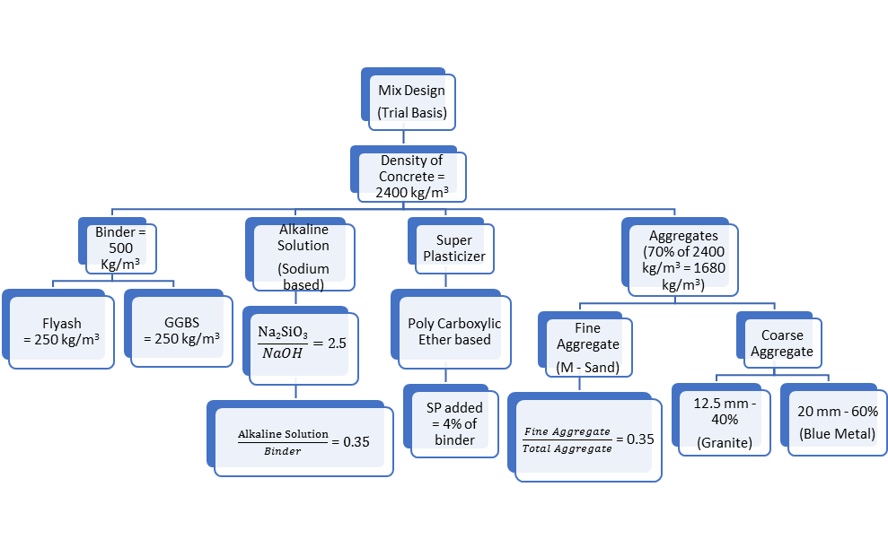Figure 1 Proposed Mix Design of Geopolymer Concrete
2.3 Mixing
For mixing, initially, the fine, as well as coarse aggregates, were prepared in saturated surface dry condition. For the preparation of alkaline solution, first, the sodium hydroxide solution for the corresponding molarity was kept ready 24 hours prior to the time of mixing. This much time is necessary for the complete dissolution of sodium hydroxide pellets in water and also for the liberation of heat from the prepared solution because this dissolution process is an exothermic reaction. At the time of mixing, the prepared NaOH solution was mixed with the sodium silicate solution as aforesaid the ratio of sodium silicate to sodium hydroxide solution is 2.5.
The mixing was done at two phases such as dry mix and wet mix. In the dry mix, the premixed FA and GGBS mixed with fine and coarse aggregates in saturated surface dry condition thoroughly. Next, the alkaline solution and superplasticizer were gradually added to the dry mix and this wet mixing was continued for about 4-5 minutes (Parveen et al. 2018). This mixing program was represented in Figure 2.
2.4 Casting and Curing of Geopolymer Concrete
Once the mixing over, the required number of specimens for finding diverse properties of Geopolymer Concrete were prepared in the corresponding moulds and these specimens were vibrated on a vibrating table for another 1 minute. All the Geopolymer Concrete specimens were cast and tested as per Indian standards IS: 516 (1959): 2004 & IS: 5816 (1999): 2004. After the completion of one day, the cast samples were demoulded and allowed for curing at an ambient temperature of 27±2°C. The cubes of size 150mm at 1, 3, 7, 14 & 28 days and cylinders of 150mm diameter with 300mm height at 7, 14 and 28 days of curing were tested for the evaluation of compressive and tensile strengths, respectively. In order to find the flexural strength of Geopolymer Concrete, the prisms of size 100mmx100mmx500mm were cast for the respective molarity of sodium hydroxide. For each test result, the average value of three specimens reported as the final strength.
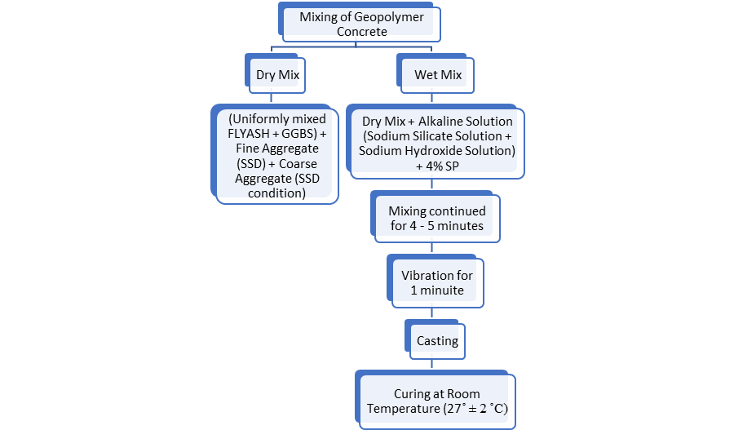
Figure 2 Preparation of Geopolymer Concrete
2.5 Non-Destructive Testing
To assess the strength of the in-situ concrete, the core samples are needed to be drawn and it should be tested in assist with the compression testing machine in the laboratory. This process is time-consuming and expensive. In order to eradicate these circumstances, Non-Destructive testing techniques are being used to evaluate the quality of concrete in the existing structure in a quick manner (Kristine Sanchez and Nathaniel Tarranza 2014). The primary objective of doing Non-Destructive tests is to control the quality of structures before used in service life and to maintain the structures in its service life. The most commonly used Non-Destructive tests are Rebound Hammer test and Ultrasonic pulse velocity test.
2.5.1 Rebound Hammer test
The Rebound Hammer is a routinely used method to measure the compressive strength of concrete in relation to the surface hardness by using a spring and plunger. The popularity of this instrument is deepened because it is a handy one, easy to use and less expensive. Initially, the test was started with the calibration of Rebound Hammer. Then the Hammer should be impacted against the surface of the concrete at the right angle to evaluate the surface hardness. But these Rebound Hammer readings are very sensitive near to the surface and many factors which may affect the surface hardness of concrete such as moisture content, presence of steel bars, carbonation of concrete, age of concrete, surface smoothness, temperature, type of cement, the existence of aggregate and air content. In this study, the Rebound Hammer test was carried out as per IS13311 (part 2: 1992): 2004.
2.5.2 Ultrasonic Pulse Velocity test
This test method is also one of the commonly used NDT methods because of its lower cost and simple operation. It is used to evaluate the presence of cracks, voids, imperfections and homogeneity of the concrete (Lawson I. et al. 2011). In this study, there are two transducers are used. One is used to emit the ultrasonic pulses and the other is intended to receive the reflected pulses through the concrete. It works on the principle of measuring the travel time of ultrasonic pulses which was reflected through the different boundaries of concrete. The factors which are influencing the measurement of pulse velocity are moisture content, surface condition, location of reinforcement, path length, temperature, shape and size of the concrete member. The measurement of high velocity denoted that the strength of concrete is high. But the presence of voids in concrete leads to increase the path length. Finally, it limits the velocity of pulses by lengthening the path of concrete through which the pulse could be reflected results in lower down the quality of concrete (Tarun Yadav et al. 2019). The pulse velocity of the Geopolymer Concrete samples was tested according to IS 13311 (part 1:1992): 2004.
3. Results and Discussions
3.1 Compressive strength
The compressive strength of Geopolymer Concrete at 1, 3, 7, 14 and 28 days of ambient curing was estimated. The FA-based Geopolymer Concrete requires a longer time to enhance the strength of the concrete. But higher proportion of GGBS that increases the higher early strength. Around 90% of the 28-day compressive strength can be achieved within 7 days of curing (Mallikarjuna G. & Kireety C.H. 2019). This development in strength due to the intrusion of slag in concrete which reduces initial as well as final setting time (Pradip Nath and Prabir Kumar Sarker 2014). Figure 3 depicts the compressive strength of FA and GGBS based Geopolymer Concrete for the NaOH molarities of 4, 6, 8, 10 and 12. From this, it was clearly visible that the rate of attainment of strength beyond 7 days was not much noticeable except 4M geopolymer concrete. It was also revealed that the concrete prepared with 4 molarity NaOH does not attain higher strength when compared to the other molarities which may due to the lower concentration of sodium hydroxide solution. The compressive strength at 28 days of ambient curing were found as 33.34MPa, 49.10MPa, 57.53MPa, 55.14MPa and 52.74MPa for 4M, 6M, 8M, 10M and 12M concretes, respectively. The highest strength was noticed in 8M concrete at the age of 28 day ambient curing. Beyond 8M, a slight declination in the strength was observed. The strength development in Geopolymer Concrete is predominantly associated with the presence of leachable alumino-silicates. Due to the excess leaching of silica at higher concentration of sodium hydroxide that hinders the Geopolymerization reaction which affects the strength of Geopolymer Concrete (Subhashree Samantasinghar & Suresh Prasad Singh 2016). The attainment of strength at 7 days was 49.46%, 88.75%, 79.54%, 88.52% and 93.38% of 28-day strength for the aforesaid Geopolymer Concretes. Except 4M Geopolymer Concrete mix, almost 80-90% of 28-day strength are obtained for remaining molarities within 7 days of curing itself (Mallikarjuna G. & Kireety C.H. 2019 and Subhashree Samantasinghar & Suresh Prasad Singh 2016). This indicates that the progress in molarity which kindles up the strength improvement. This much amount of development in compressive resistance at room temperature is due to the existence of calcium content in GGBS and the presence of alumina and silica in FA. The higher strength development in Geopolymer concrete is achieved due to the formation of sodium aluminate silicate hydrate gel (NASH) and calcium aluminate silicate hydrate gel (CASH) which are the end product of polymerization reaction between alkaline solution and silica-alumina rich source materials (Mehta A & Siddique R 2017). In addition with these gel products, the calcium content which forms the CSH gel similar to that of Ordinary Portland Cement concrete (Praveen et al. 2018).

Figure 3 Variation in Compressive strength for different molarities
3.2 Splitting tensile strength
The splitting tensile strength of Geopolymer Concrete for the varying molarity was done in accord with IS 5816 (1999): 2004. The tensile strength as well as flexural strength of Geopolymer Concrete is depends well on the bond strength of aggregate-gel (Arie Wardhono et al. 2017). Some of the researcher were reported that it is also adhered to the slag/FA particles distribution and their microstructure formation (C. Gunasekara et al. 2015 and C. Tennakoon et al. 2014). The splitting tensile strength results for various concentration of NaOH is shown in Figure 4. From the test results, it is noticed that only 6-8% of compressive resistance was achieved as splitting tensile strength which is similar to that of conventional concrete (Subhash V. Patankar et al 2015). Due to the smooth surface of FA grain with average size of 45µm, the FA based Geopolymer Concrete showed lesser tensile strength than Geopolymer Concrete incorporated with GGBS. This was happened due to the strong bond between binder and aggregate because of the rough surface of GGBS (Ghina M. zannerni et al. 2020). Hence, the negative effects of FA may be balanced by the addition of GGBS in Geopolymer Concrete blended with FA and GGBS.

Figure 4 Splitting tensile strength of Geopolymer Concrete
In this paper, the 7 day splitting tensile strength of FA & GGBS based Geopolymer Concrete is in the range of 1.39 – 2.66 MPa for different molarities of Geopolymer Concrete. Almost 50-80% of 28-day tensile strength was developed at 7 days of ambient curing. The rate of attainment of tensile strength at 7 days of curing is higher for Geopolymer Concrete (Gautam et al. 2015). The curing condition of Geopolymer Concrete plays on important role in the development of tensile strength. Longer curing duration at elevated temperature led to increase the tensile strength of Geopolymer Concrete than ambient cured Geopolymer Concrete (K.T. Nguyen at al. 2016).
Figure 5 shows a correlation between the compressive strength (f_{c}) and splitting tensile strength (f_{ct},_{sp}) test results found at 28 days of curing. The proposed equation (1) which depicts the relation between two variables of this FA – GGBS based Geopolymer Concrete cured at ambient temperature.
f_{ct},_{sp =} 0.44 √f_{c} MPa (1)

Figure 5 Relationship between splitting tensile strength & compressive strength
The equation (1) is well coordinated with the equation (2) which was found by the researcher (C. Gunasekera et al. 2017)
f_{ct}._{sp =} 0.45 √f_{c} MPa (2)
Ryu et al. suggested an equation that represents the connection between compressive strength and split tensile strength as f_{sp =} 0.17 (f_{c}’)^{3/4} MPa for FA based Geopolymer Concrete. But this equation is underestimate the tensile strength for GGBS based Geopolymer Concrete (Ryu et al. 2013). The American Concrete Institute ACI 363 R (ACI 1992) and Australian Standards AS 3600 (AS 2009) recommended models with equations (3 & 4) to define the link between compressive and splitting tensile strengths for conventional concrete.
f’'_{sp} = 0.59 √f’_{c} MPa (3)
f’_{ct}._{sp} = 0.4 √f’_{c} MPa (4)
From the equation 3 & 4, the ACI 363 R (ACI 1992) which overestimates the splitting tensile strength of Geopolymer Concrete, But, the Australian Standards AS 3600 (AS 2009) gives conservative value regarding the prediction of tensile strength of Geopolymer Concrete (C. Gunasekera et al. 2017).
3.3 Flexural strength
Strength of concrete that was found against flexure can be used as tensile strength. Moreover, the flexural strength is usually higher than the splitting tensile strength of concrete (Pradip Nath et al. 2016). The flexural strength of ambient cured Geopolymer Concrete test results shows similar trend as that of compressive strength. The Geopolymer Concrete cured at room as well as elevated temperature achieved higher flexural strength than that of OPC concrete because of strong bond between aggregate and Geopolymer binder (Hardjito et al. 2005 and P.S. Deb et al. 2014). In this paper, the 28-day flexural strength of Geopolymer Concrete was done by referring IS 516 (1959): 2004. The obtained results are varied from 3.45 MPa to 4.55 MPa. This value is about 8-10% of the corresponding 28-day compressive resistance of Geopolymer Concrete. When compared to FA based Geopolymer Concrete, the Geopolymer Concrete made with GGBS reaches higher flexural strength (Yong Hu et al. 2019). The precipitation of alumino-silicate gel and dissolution of alkali content over the surface of aggregate that plays vital role on the development of tensile strength and flexural strength of Geopolymer Concrete (Arie Wardhono et al. 2017).
3.3.1 Relation between flexural strength and compressive strength
The Figure 6 depicts a scatter plot that represents the relation between flexural strength and compressive strength. The projected regression model gives an equation as
f_{ct} = 0.59 √f_{c} MPa (5)
Where, f_{ct} is the mean flexural strength at 28-day curing and f_{c} denotes the average compressive strength at 28-day. In the figure 6, the linear regression line is made between the two variables that expressing a R² value of 0.9993.

Figure 6 Compressive strength versus Flexural Strength
The recommended mean flexural strength (f’_{ct,f}) in associate with the compressive strength (f’_{c}) as per Australian Standards of AS 3600 – 2009 is provided as
f’_{ct,f} = 0.6 √f’_{c} MPa (6)
American Concrete Institute proposed an equation (7) to predict the flexural strength in the code of ACI 318-14 and Indian Standard of IS 456:2000 derived an equation (8) to find the flexural strength (f_{cr}) as follows
f_{ct,f} = 0.62 √f’_{c} MPa (7)
f_{cr} = 0.7 √f_{ck} MPa (8)
f_{ct,f} & f_{cr} are the average compressive strength of concrete. The flexural strength of Geopolymer Concrete cured at room temperature found by experimental results are reported lower value than the codal specifications developed for conventional concrete. By referring the equations (5-8) and experimental test results, the equation used to estimate mean flexural strength recommended by Australian Standards for OPC concrete can be used for ambient cured Geopolymer Concrete with marginal factor of safety (P. Nath et al. 2016).
4. Analysis of test results
4.1 Compressive strength predicted by Destructive and Non-Destructive tests
In order to understand the effect of molarity on Geopolymer Concrete the Destructive (DT) and Non-Destructive (Rebound Hammer and Ultrasonic Pulse Velocity) tests (NDT) were conducted at 1, 3, 7, 14 and 28 days of ambient curing as shown in Figure 7 and 8. A regression analysis was carried out to find the linear regression equation and the corresponding coefficient (R²) between the results obtained from the Destructive and Non-Destructive tests.
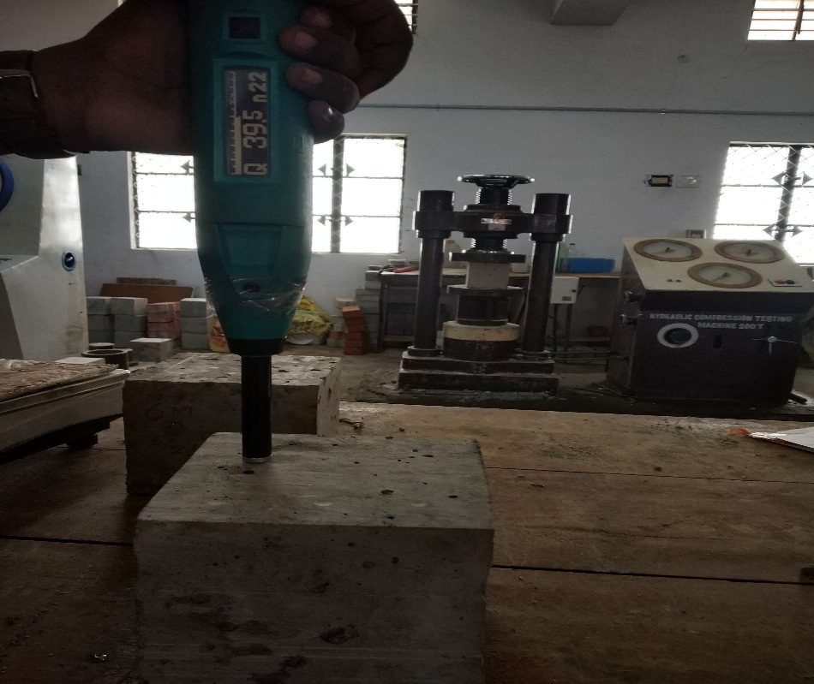
Figure 7 Rebound Hammer test
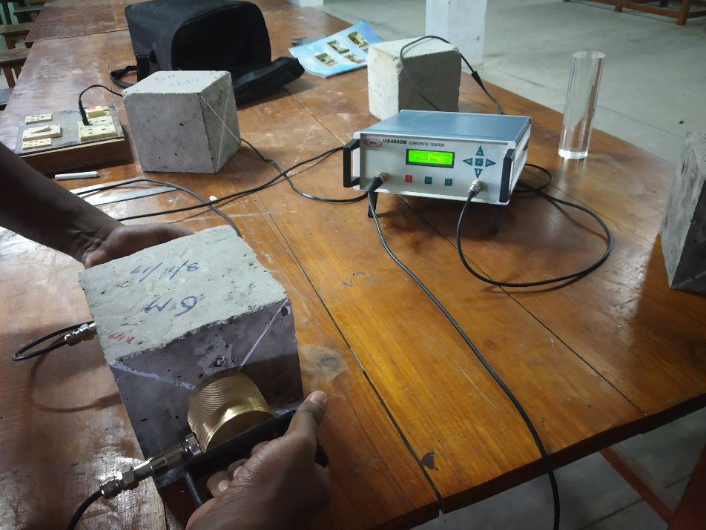
Figure 8 Direct Ultrasonic pulse velocity test
The ultrasonic pulse velocity, average compressive strength calculated from the Rebound Hammer test and the quality of concrete also were listed in Table 3. In the Geopolymer Concrete produced with 4M concentration of sodium hydroxide does not have a Rebound Hammer number at the early age of 1 day. It gives the compressive strength of 10.45MPa at 3 days of curing. This concrete mix requires sufficient time for achieving a Geopolymerization reaction to develop the required resistance against a load. The quality of Geopolymer Concrete are accessed with the obtained test results by referring the standard values of IS 13311 (part 1:1992): 2004 and The Concrete Society, 2000. From the table 3 representation, all the other Geopolymer Concrete mixes come under the quality of Good and Excellent because the ultrasonic pulse velocity varies from 3.62km/s to 4.79 km/s. The highest ultrasonic pulse velocity was found at 28 days open cured samples made with 8M and also the ultimate compressive strength estimated by the Rebound Hammer test was 42.11MPa for the same 8M Geopolymer Concrete.
To validate the experimental results, the regression analysis has been carried out between the compressive strength by DT vs. compressive strength by Rebound Hammer and compressive strength by DT vs compressive strength by Ultrasonic Pulse Velocity. The regression equation and the R² value between Compressive strength by DT vs. Rebound Hammer test and Compressive strength vs Ultrasonic pulse velocity test were pictured in Figures 9 and 10 respectively. From this graph, there was a very good positive correlation has been found for all molarities. For the confirmation of the Rebound Hammer test result with Destructive compressive strength, the acquired R² value varies from 0.9332 to 0.9836. Likewise, for the Ultrasonic pulse velocity test, it differs from 0.8970 to 0.9967. The value of R² gives the variance of the dependent variable which is estimated in terms of the independent variable (Sumathy Raju and Brindha Dharmar 2016). From these values, the expected results are well correlated with experimental results. The compressive strength of Geopolymer Concrete mixes (f_{ck, RHT}) were calculated from the Rebound Number (RN) by using the equation (9)
f_{ck, RHT} = 0.0069 (RN)² + 0.493 (RN) MPa (9)

Table 3 Non-Destructive Test results and Quality of Geopolymer Concrete
Name of the test | Curing period | 4M | 6M | 8M | 10M | 12M
Compressive strength by Rebound Hammer test in MPa | 1 Day | 0.00 | 20.03 | 17.65 | 21.76 | 22.12
 | 3 Day | 10.45 | 26.80 | 24.72 | 30.79 | 29.64
 | 7 Day | 18.67 | 32.96 | 32.93 | 37.14 | 34.34
 | 14 Day | 24.49 | 33.89 | 40.03 | 40.87 | 39.04
 | 28 Day | 28.95 | 39.38 | 42.11 | 41.04 | 40.15
Quality of concrete as per The Concrete Society (2000) | 28 Day | Fair  (20-30) | Good  (30-40) | Very Good  (>40) | Very Good  (>40) | Very Good  (>40)
Ultrasonic pulse velocity in km/s | 1 Day | 2.81 | 3.81 | 3.62 | 3.95 | 4.12
 | 3 Day | 2.91 | 4.31 | 4.22 | 4.44 | 4.33
 | 7 Day | 3.71 | 4.45 | 4.61 | 4.60 | 4.59
 | 14 Day | 4.12 | 4.59 | 4.65 | 4.64 | 4.65
 | 28 Day | 4.28 | 4.61 | 4.79 | 4.72 | 4.70
Quality of concrete as per The Concrete Society (2000) | 28 Day | Good  (3.66-4.57) | Excellent  (>4.57) | Excellent  (>4.57) | Excellent  (>4.57) | Excellent  (>4.57)
Quality of concrete at as per IS 13311 (part 1) : 1992 | 28 Day | Good  (3.5-4.5) | Excellent  (>4.5) | Excellent  (>4.5) | Excellent  (>4.5) | Excellent  (>4.5)

Figure 9 Compressive strength by DT vs Rebound Hammer

Figure 10 Compressive strength by DT vs UPV
5. Carbon dioxide emission: Comparison
There is huge amount of CO₂ emission is reported by cement industries due to the following causes: i) high energy is consumed during the kiln operation ii) limestone calcination that liberates much carbon dioxide to the environment (Louise K. Turner & Frank G. Collins 2013). But, the invention of blended cement that reduces the CO₂ emission up to 13-22% (Flower DJM & Sanjayan G 2007). This estimation may vary depending upon the quantity of binder required, sources of raw materials, quantity of Ordinary Portland Cement replacement, climate conditions, distance of transportation and facilities available locally for the manufacturing of concrete. In case of alkali activated concrete, the CO₂ emission was observed as 45% less when compared to carbon dioxide emission related with traditional concrete production (Turner and Collin 2013). Other studies are reported that the much utilization of industrial waste products in Geopolymer Concrete which cut down 70-75% CO₂ emission as compared to OPC concrete (Sanjay Pareek et al. 2019 and Keun-Hyeok Yang et al. 2013).
6. Conclusion
This paper was presented to study the effect of molarity on Geopolymer Concrete and the suitability in the construction industry to minimize the emission of carbon-di-oxide. From the experiment results, the following conclusions were identified
1. In FA and GGBS based Geopolymer Concrete, the incorporation of calcium present in GGBS has enhanced the strength at early ages itself. The 3-day and 7-day strengths were around 50-75% and 80-93% of 28 days compressive strength except for 4M geopolymer concrete.
2. The Geopolymer Concrete made with 4M sodium hydroxide addition does not develop adequate strength at an early curing period of 1-day and 3-days. Because this concentration is not enough to achieve the Geopolymerization reaction at the initial stage.
3. The compressive strength of Geopolymer Concrete generally increases with increasing the molarity of sodium hydroxide. But the ultimate strength was predictable as 57.53MPa at 28-days curing 8M Geopolymer Concrete.
4. The 28-day splitting tensile and flexural strengths for various molarities of Geopolymer Concrete ranged between 2.80 – 3.40 MPa and 3.45 – 4.35 MPa respectively. But, these values are only a proportion of compressive resistance for corresponding curing.
5. The design equation provided in Australian Standard AS 3600 – 2009 for the prediction of flexural strength gives conservative results for ambient cured Geopolymer Concrete.
6. The trend which is obtained from the compressive strength test results was maintained similarly in the other mechanical properties like splitting tensile strength and flexural strengths of Geopolymer Concrete.
7. The compressive strength predicted by the Rebound Hammer test was lower than that of strength which was estimated by Destructive test. This may be due to factors like surface moisture, smoothness, air content, etc. affects the Rebound Hammer number.
8. Apart from the ultrasonic pulse velocity of 4M Geopolymer Concrete at early ages (1 day and 3 days), the remaining concrete having the velocity range of 3.62km/s-4.79km/s belongs to a good and excellent quality.
9. In regression analysis, the linear equations were well suited to the experimental results obtained from the Destructive and Non-Destructive test results. The coefficient (R²) value was diverges from 0.9475 to 0.9967.
10. It was clearly described that the 4M Geopolymer Concrete attains the target strength of M25 and all other concrete moulded with other molarities reaches the target strength of M40 grade of conventional concrete.
11. From this study, Geopolymer Concrete production should be encouraged to minimize the effect of global warming by effectively utilizing industrial by-products and make cement-free concrete.
Acknowledgements
The authors would like to thank the Government College of Engineering, Tirunelveli for conducting the Experimental works.
Conflict of Interest
There is no conflict of interest.
References
ACI 318-14, Building code Requirements for Structural Concrete and Commentary, American Concrete Institute, Farmington Hills, MI 48331, U.S.A., 2014.
Al Muhit B.A., Foong K.Y., Alengaram U.J., Mohd. Z .Jumaat (2013), Geopolymer concrete: A Building Material for the Future, Electronic Journal of Structural Engineering, 13(1), 11-15.
Ankur Mehta and Rafat Siddique (2017), Strength, permeability and micro-structural characteristics of low-calcium fly ash based geopolymers, Construction and Building Materials, 141, 325-334.
Anuradha A., Sreevidya V., Venkatasubramani R. and Rangan B.V. (2012), Modified Guidelines for Geopolymer concrete mix design using Indian Standards, Asian Journal of Civil Engineering (Building and Housing), 13, 353-364.
Arie Wardhono, C. Gunasekera, David W. Law, Sujeeva Setunge, (2017), Comparison of long term performance between alkali activated slag and fly ash geopolymer concretes, Construction and Building Materials, 143, 272-279.
AS 3600-2009, Concrete Structures, Standards Australia 2009.
Davidovits J. (1979), Synthesis of new high temperature geo-polymers for reinforced plastics/composites, SPE PACTEC, 79, 151-154.
De Silva P., Sagoe-Crenstil K. and Sirinivatnanon V., (2007), Kinetics of Geopolymerization: role of Al₂O₃ and SiO₂, Cement and Concrete Research, 37(4), 512-518.
Deb P.S., Nath P., Sarker P.K., (2014), The effects of ground granulated blast-furnace slag blending with fly ash and activator content on the workability and strength properties of geopolymer concrete cured at ambient temperature, Materials and Design, 62, 32-39.
Ferdous M.W., Kayali O. and Khennane A., (2013), A detailed procedure of mix design for fly ash based Geopolymer concrete, Fourth Asia-Pacific Conference on FRP in Structures, Melbourne, Australia.
Flower D.J.M., Sanjayan J.G., (2007), Greenhouse gas emissions due to concrete manufacture, International Journal of Life Cycle Assessment, 12(5), 282-288.
Gautam L., Prema Kumar W.P., Sheethal K.T and Prathap Kumar M.T., (2015), International Journal of Engineering Research & Technology, 4(7), 194-200.
Ghina M. Zannerni, Kazi P.Fattah, Adil K. Al-Tamimi, (2020), Ambient-cured geopolymer concrete with single alkali activator, Sustainable Materials and Technologies, 23, e00131, https://doi.org/10.1016/j.susmat.2019.e00131.
Gopalakrishnan R., and Chinnaraju K., (2019), Durability of ambient cured alumina silicate concrete based on slag/fly ash blends against sulfate environment, Construction and Building Materials, 204, 70-83.
Gunasekera C., et al, (2015), Zeta potential, gel formation and compressive strength of low calcium fly ash geopolymers, Construction and Building Materials, 95, 592-599.
Gunasekera C., Sujeeva Setunge and David W. Law, (2017), Correlations between Mechanical Properties of Low-Calcium Fly Ash Geopolymer Concretes, ASCE Journal of Materials in Civil Engineering, DOI: 10.1061/(ASCE)MT.1943-5533.0001916.
Hardjito D. and Rangan B.V., (2015), Development and properties of Low Calcium Fly ash based Geopolymer concrete, Research Report GC1, Faculty of Engineering, Curtin University of Technology, Perth.
Heah C.Y., Kamarudin A.M., Mustafa Al Bakri A.M., Binhussain M., Luqman M., Khairul Nizar I., Ruzaidi C.M. and Liew Y.M., (2011), Effect of Curing Profile on Kaoline-based Geopolymers, Physics Procedia, 22, 305-311.
IS 10262-2009, Recommended Guidelines for Concrete Mix Design.
IS 13311 (part 1: 1992): 2004, Indian Standard Specification for Non-Destructive testing of concrete Methods-Of Test - Part 1 Ultrasonic Pulse Velocity, Bureau of Indian Standards, New Delhi, India.
IS 13311 (part 2: 1992): 2004, Indian Standard Specification for Non-Destructive testing of concrete Methods-Of Test - Part 2 Rebound Hammer, Bureau of Indian Standards, New Delhi, India.
IS: 383 (1970): 2002, Indian Standard Specification for Coarse and Fine Aggregates from Natural Sources for Concrete, Bureau of Indian Standards, New Delhi, India.
IS: 516 (1959): 2004, Indian Standard Methods of Tests for Strength of Concrete, Bureau of Indian Standards, New Delhi, India.
IS: 5816 (1999): 2004, Indian Standard Splitting Tensile Strength of Concrete – Method of Test, Bureau of Indian Standards, New Delhi, India.
Jewell S., and Kimball S., (2015), USGS mineral commodities summaries: 2015, US Geological survey, http://minerals.usgs.gov/minerals/pubs/mcs/2014/mcs2015.pdf.
Keun-Hyeok Yang, Jin-Kyu Song, Keum-II Song, (2013), Assessment of CO₂ reduction of alkali-activated concrete, Journal of Cleaner Production, 39, 265-272.
Khoa Tan Nguyen, Namshik Ahn, Tuan Anh Le, Kihak Lee, (2016), Theoretical and experimental study on mechanical properties and flexural strength of fly ash-geopolymer concrete, Construction and Building Materials, 106, 65-77.
Kristine Sanchez and Nathaniel Tarranza, (2014), Reliability of Rebound Hammer Test in Concrete Compressive Strength Estimation, International Journal of Advances in Agricultural and Environmental Engineering, 1(2), 198-202.
Lawson I., Danso K.A., Odoi H.C., Adjei C.A., Quashie F.K., Mumuni I.I. and Ibrahim, (2011), Non-Destructive Evaluation of concrete using Ultrasonic Pulse Velocity, 3(6), 499-504.
Lloyd N.A. and Rangan B.V. (2010), Geopolymer Concrete with fly ash, Second International Conference on Sustainable Construction Materials and Technologies, Univesita Politecnica delle Marche, Ancona, Italy.
Louise K. Turner and Frank G. Collins, (2013), Carbon dioxide equivalent (CO₂–e) emissions: A comparison between geopolymer and OPC cement concrete, Construction and Building Materials, 43, 125-130.
Malhotra V.M., (1999), Making concrete greener with fly ash, ACI Concrete International, 21, 61-66.
Mallikarjuna Rao G. and Kireety C.H., (2019), Durability Studies on Alkali Activated Fly Ash and GGBS-Based Geopolymer Mortars, Sustainable Construction and Building Materials, Lecture Notes in Civil Engineering 25, https://doi.org/10.1007/978-981-13-3317-0_8.
Muhammad Zahid, Nasir Shafiq and Asif Jalal, (2018), Investigating the effects of solarcure curing method on the compressive strength, microstructure and polymeric reaction of fly ash based geopolymer, Construction and Building Materials 181, 227-237.
Parveen, Dhirendra Singhal, Talha Junaid M., Bharat Bhushan Jindal and Ankur Mehta, (2018), Mechanical and microstructural properties of fly ash based geopolymer concrete incorporating alccofine at ambient curing, Construction and Building Materials, 180, 298–307.
Pavithra P., Srinivasula Reddy M., Pasla Dinakar, Hanumantha Rao B., Satpathy B.K., and Mohanty A.N., (2016), A mix design procedure for geopolymer concrete with fly ash, Journal of Cleaner Production, 133, 117-125.
Peter Levi, Tiffany Vass, Hana Mandova and Alexandre Gouy, (2019), Global Cement Production, International Energy Agency (IEA), https://www.iea.org/reports/cement.
Pradip Nath and Prabir Kumar Sarker, (2014), Effect of GGBFS on setting, workability and early strength properties of fly ash geopolymer concrete cured at ambient condition, Construction and Building Materials, 66, 163-171.
Pradip Nath and Prabir Kumar Sarker, (2016), Flexural strength and elastic modulus of ambient-cured blended low-calcium fly ash geopolymer concrete, Construction and Building Materials, https://dx.doi.org/10.1016/j.conbuildmat.2016.11.034.
Ramin Hosseini Kupaei, Johnson Alengaram U., Mohd Zamin Bin Jumaat and Hamid Nikraz, (2013), Mix design for fly ash based oil palm shell geopolymer lightweight concrete, Construction and Building Materials, 43, 490-496.
Ravitheja A. and Kiran Kumar N.L.N., (2019), Effect of Nano-Silica and GGBS on the Strength Properties of Fly Ash-Based Geopolymers, Sustainable Construction and Building Materials, Lecture Notes in Civil Engineering 25, https://doi.org/10.1007/978-981-13-3317-0_40.
Ryu G.S., Lee Y.B., Koh K.T., Chung Y.S., (2013), The mechanical properties of fly-ash based geopolymer concrete with alkaline activators, Construction and Building Materials, 47, 409-418.
Sanjay Pareek, Hiroo Kashima, Ippei Maruyama and Yoshikazu Araki, (2019), Adhesion characteristics of geopolymer mortar to concrete and rebars, MATEC Web of Conferences, SCESCM 2018, 258, 01012, https://doi.org/10.1051/matecconf/201925801012.
Sanjeev Kumar Verma, Sudhir Singh Bhadauria and Saleem Akhtar, (2013), Review of Nondestructive Testing Methods for Condition Monitoring of Concrete Structures, Hindawi Publishing Corporation Journal of Construction Engineering, 1-11.
Subhash V. Patankar, Yuwaraj M. Ghugal and Sanjay S. Jamkar, (2015), Mix Design of fly ash based Geopolymer Concrete, Advances in Structural Engineering, 1619-1634.
Subhashree Samantasinghar and Suresh Prasad Singh, (2016), Synthesis of fly ash-GGBS blended Geopolymer Composits, Indian Geotechnical Conference, IIT Madras, Chennai, India.
Sudipta Naskar and Arun kumar Chakraborty, (2016), Effect of Nano materials in Geopolymer concrete, Perspectives in Science, 8, 273-275.
Suhendro B., (2014), Toward green concrete for better sustainable environment, Procedia Eng, 95, 305-320.
Sumathy Raju and Brindha Dharmar, (2016), Mechanical properties of concrete with copper slag and fly ash by DT and NDT, Periodica Polytechnica Civil Engineering, 60(3), 313-322.
Tarun Yadav, Jatin Singh, Sandeep Panchal, Md. Moshin Khan and Shilpa Pal, (2019), Analysis of Effect of Ground Granulated Blast Furnace Slag (GGBFS) on the Mechanical Properties of concrete using Destructive and Non-destructive Tests, Journal of mechanics of continua and mathematical sciences, 14(1), 78-90.
Tennakoon C., et al, (2014), Distribution of oxides in fly ash controls strength evolution of geopolymers, Construction and Building Materials, 71, 72-82.
The Concrete Society, (2000), Diagnosis of deterioration in concrete structures, Technical Report No. 54, Berkshire, Crowthorne.
Van Oss H.G., (2013), Cement. U.S. Geological survey, Accessed from http://minerals.usgs.gov/minerals/pubs/commodity/cement/mcs-2013-cemen.pdf.
Wilson A.P., (2015), Establishing a mix design proczedure for Geopolymer concrete.
Yong Hu, Zhuo Tang, Wengui Li, Yunan Li, Vivian W.Y. Tam, (2019), Physical-mechanical properties of fly ash/GGBFS geopolymer composites with recycled aggregates, Construction and Building Materials, 226, 139-151.

List of Tables
Table 1 Physical properties of fine and coarse aggregate
Table 2 Proportions of materials for 1 m³ of Geopolymer Concrete
Table 3 Non-Destructive Test results and Quality of Geopolymer Concrete
List of Figures
Figure 1 Proposed Mix Design of Geopolymer Concrete
Figure 2 Preparation of Geopolymer Concrete
Figure 3 Variation in Compressive strength for different molarities
Figure 4 Splitting tensile strength of Geopolymer Concrete
Figure 5 Relationship between splitting tensile strength and compressive strength
Figure 6 Compressive strength versus Flexural Strength
Figure 7 Rebound Hammer test
Figure 8 Direct Ultrasonic pulse velocity test
Figure 9 Compressive strength by DT vs Rebound Hammer
Figure 10 Compressive strength by DT vs UPV

